

**FPT ACADEMY INTERNATIONAL**

**FPT – APTECH COMPUTER EDUCATION**

Funky Fruit Music

eProject Report Semester 2

|  |  |  |
| --- | --- | --- |
| **Supervisor** | Ngo Phuoc Nguyen | |
| **Batch** | T1.1910.M3 | |
| **Group** | 2 | |
| **Serial No.** | **Student Name** | **Enrollment Number** |
| 1. | Lư Hán Luân | Student1225547 |
| 2. | Đào Nguyễn Duy Khang | Student1225621 |
| 3. | Châu Đức Thịnh | Student1228771 |

**August – 2020**

**This is to certify that**

**Mr./Ms.:**

LƯ HÁN LUÂN

ĐÀO NGUYỄN DUY KHANG

CHÂU ĐỨC THỊNH

**Has successful design & developed:** eProject:

Funky Fruit Music

**Submitted by:** Lư Hán Luân

**Date of issue:** August – 2020

**Authorized Signature:**

**_______________________________________**

TABLE OF CONTENTS:

**ACKNOWLEDGEMENT** 7

**REVIEW 1** 8

**INTRODUCTION** 9

**PROBLEM DEFINITION** 10

**CUSTOMER REQUIREMENT SPECIFICATION** 11

**SCOPE OF WORK** 13

**SYSTEM REQUIREMENT SPECIFICATION** 13

**Hardware** 13

Web Server 13

Client 14

**Software:** 14

Web Server 14

Client 14

**TASK SHEET REVIEW 1** 16

**REVIEW 2** 17

**USECASE AND SEQUENCE DIAGRAM** 18

I. Add song: (admin) 19

II. Add singer (admin) 20

III. Searching data function (user): 21

IV. Create playlist (user): 22

V. Login (User) 23

**ENTITY RELATIONSHIP DIAGRAM** 24

**TABLE DESIGN** 25

I. Table Users: 25

II. Table Roles: 25

III. Table Songs: 26

IV. Table Categories: 26

V. Table Singers: 27

VI. Table Musicians: 27

VII. Table Subcribers: 27

VIII. Table Comments: 28

IX. Table detailsongs: 28

X. Table views: 28

XI. Table nations: 28

XII. Table Views: 29

XIII. Table detailplaylists: 29

XIV. Table albums: 29

XV. Table detailalbums: 29

**FLOWCHART DIAGRAM** 30

I. Search 30

II. Register (user) 31

III. Login (user) 32

IV. Login (admin) 33

**SITEMAP** 34

**TASK SHEET REVIEW 2** 35

**REVIEW 3** 36

**I.** **Admin:** 37

1. Login: 37

2. Dashboard: 38

3. Role: 39

4. User: 40

5. User (Add new): 41

6. Nations: 42

7. Categories: 43

8. Musicians: 44

9. Musicians (view): 45

10. Musicians (edit): 46

11. Singers: 47

12. Songs: 48

13. Songs (view): 49

14. Songs (edit): 50

15. Albums: 51

16. Comments: 52

17. Settings: 53

**II.** **User:** 54

1. Homepage: 54

2. New-release: 56

3. Song: 57

4. Albums: 58

5. Album-detail: 59

6. Singers: 60

7. Singer-detail: 61

8. Musicians: 62

9. Musician-detail: 63

10. Categories: 64

11. Category-detail: 65

12. Nations: 66

13. Nation-detail: 67

14. About us: 68

15. Recent songs: 69

16. Liked songs: 70

17. Search: 71

18. Login (user): 73

19. Register (user): 74

**TASK SHEET REVIEW 3** 75

# **ACKNOWLEDGEMENT**

Our group would like to devote this chapter to express our deepest appreciation to all those who offered us valuable assistance during in carrying out this eProject.

First and foremost, we owe a debt of gratitude to our dedicated instructor, Mr. Ngo Phuoc Nguyen, whose suggestions and encouragement helped us to overcome not only technological challenges but also psychological tension. Without him, our work could not have been completed successfully.

Secondly, we highly appreciate the eProject Team at the Head Office which has provided us a golden opportunity to apply what we learned into practice. We are certain that the experiences we gained from this project will facilitate our future career greatly. Besides, we would also like to express my gratitude to all the staff members of my center for not only providing me with the opportunity to work with them on this project, but also for their support and encouragement throughout the process.

Finally, we wish to say a personal thank you to all our dear classmates and team members who are always willing to support us openly and enthusiastically.

# **REVIEW 1**

# **INTRODUCTION**

During the period of information technology and computer development, music is indispensable in our life. Therefore, we are developing a music website Funky Fruit Music so that “Music makes the world go round”.

Funky Fruit Music is a group of people who wants to develop an online site where the user can listen to music everywhere, everytime around the world. It has some services below:

**For** Funky Fruit Music **customers:**

* Provide an interactive GUI, on the World Wide Web for the user.
* User can search any song and the web will show them the song they want to listen.
* User can comment, rating on that song, too.
* User can view musician, singer.
* User can create his/her own playlist.
* User can listen to famous music album.

# **PROBLEM DEFINITION**

After reading the project specifications of Funky Fruit Music, our group has discussed about what should to be done to fulfil their requirements properly. We came to conclusion that in order to achieve the best result, we should deal with following queries:

**From the view point of users**

1. How can the customer listen to the song they want?
2. How can the customer search the song easily?
3. How does the customer keep track their history what song they listened to recently?
4. How can the customers review song they want to review?
5. How can the customer login?

**From the view point of the Administrator**

1. How can the admin create new song?
2. How can the admin read, update song lyrics?
3. How can the admin see subscribers list?
4. How can the admin manage the album?
5. How can the admin view playlist of users?
6. How can admin get the statistics of which is the most viewed song?

**CUSTOMER REQUIREMENT SPECIFICATION**

**Client:** Funky Fruit Music.

**Business/Project Objective:** The project is to design a service online for listening to music.

**Input to the system:**

**Funky Fruit Music administrators need to provide:**

* + Information required in order to create account to access to the admin system.
  + Information about the songs going to be shown on the website.

**Funky Fruit Music website visitors need to provide:**

* + Personal information to create an account.

**Output from the system:**

**Funky Fruit Music administrators will be able to:**

* + Login/Logout to the admin system.
  + Manage (view, add, search, update, and delete) songs.
  + Manage (view, add, search, update, and delete) albums.
  + Manage (view, add, search, update, and delete) category of song.
  + Manage (view, add, search, update, and delete) nation of song.
  + Manage (view, search) registered customers.
  + Manage (view, add, search, update, and delete) comment.

**Funky Fruit Music’s website visitors will be able to:**

* If visitors are guests:
* Search what song they want to listen to.
* View the musician and singer information
* View review about the song
* View albums
* Download the song
* If visitors are registered members:
  + Login or logout.
  + Review, comment the song
  + Change personal information
  + Check recent, liked songs

# **SCOPE OF WORK**

The application should perform the following functions:

**Login:**

* There are 2 types of account in the application (“admin” and “user”). Administrator will login as “admin” and Customer will login as “user”.
* Two accounts must be registered and login for using the functionality of the application.
* For “admin”: can view the customer id name, add new/modify.
* For “user”: can change the profile, change their password, register new account.

**Review Song:**

* When user view a song, they can review that song in the box below the song’s information.

**Database**

* The information about songs, singers, musicians, categories, … will be stored in the database, and users can view on the Web.

**Security:**

* The user password will be encrypted and stored in the database.

# **SYSTEM REQUIREMENT SPECIFICATION**

## **Hardware**

### Web Server

|  |  |
| --- | --- |
| Processor | Intel Core i5 or higher. |
| Memory | 4 GB RAM or greater. |
| Modem/ADSL | Connecting to internet 24/24 |

### Client

|  |  |
| --- | --- |
| Processor | Intel Core i3 or higher. |
| Memory | 2 GB RAM or greater. |
| Monitor | Super VGA (1024x768) or higher resolution |
| Modem/ADSL | Connecting to internet |

## **Software:**

### Web Server

|  |  |
| --- | --- |
| Operation System | Windows 7 or higher |
| Browser | Chrome version 35 or Microsoft Edge. |
| Database | MySQL |
| Software | XAMPP |
| Laravel |
| Visual Studio Code |

### Client

|  |  |
| --- | --- |
| Operation System | Windows 7 or higher |
| Browser | Chrome version 35 or Microsoft Edge. |

**2.1 Development software**

* + Microsoft Windows 10
  + XAMPP
  + Visual Studio Code
  + Laravel
  + Git/ Github

**2.2 Technology**

* PHP
* Laravel
* Voyager
* Carbon
* Json
* nodeJS
* HTML, CSS and Javascript
* Ajax

# **TASK SHEET REVIEW 1**

|  |  |  |  |  |  |  |  |
| --- | --- | --- | --- | --- | --- | --- | --- |
| **Project Ref. No.:**  **TRAVEL ToVN** | | **Project Title:** | **Activity Plan Prepared By:** | **Date of Preparation of Activity Plan:** | | | |
| **Sr.No.** | **Task** | **Actual Start Date** | **Actual Days** | **Team Mate Names** | **Status** |
| 1 | Introduction and Problem Definition | Funky Fruit Music | Lư Hán Luân | 20/07/2020 | 1 | - Lư Hán Luân  - Đào Nguyễn Duy Khang  - Châu Đức Thịnh | 100% |
| 2 | Customer Requirement Specification (CRS) | 20/07/2020 | 1 | 100% |
| 3 | Functional Requirement | 20/07/2020 | 1 | 100% |
| 4 | System Requirement Specification |

# **REVIEW 2**

# **USECASE AND SEQUENCE DIAGRAM**

## Add song: (admin)

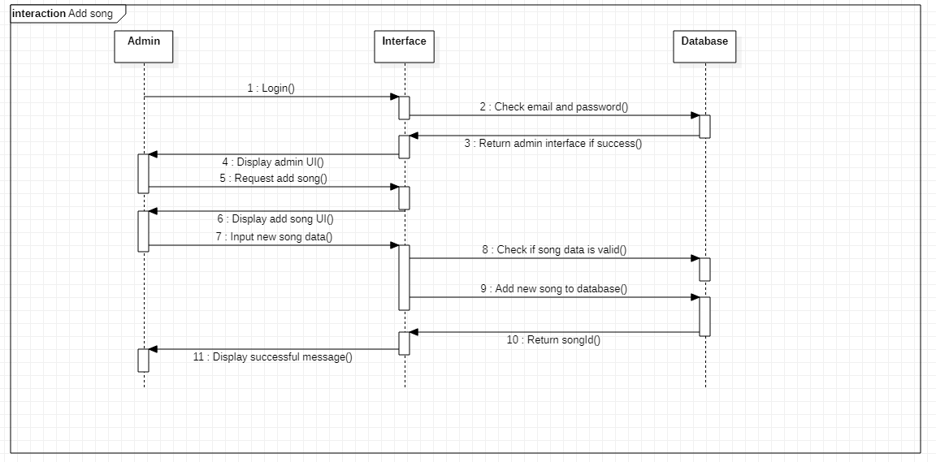

|  |  |
| --- | --- |
| **Author** | Lư Hán Luân |
| **Usecase Name** | Add song (admin) |
| **Actor(s)** | Admin |
| **Description** | Admin add a new song to database |
| **Pre-condition(s)** | * Admin has account with role admin. * Internet connection is stable. |
| **Basic Flow** | 1. Admin login to the system. 2. System validates login information. 3. Return login success. 4. Display admin UI. 5. Select song tab and press “add”. 6. Display add song interface. 7. Input new song data. 8. Check if the input data is valid. 9. Add new song to database. 10. Return new songId to interface. 11. Display successfully message. |
| **Exception Flow** | * 1. Return login fail message if admin login fail.   8.1 If the data is not valid, return add fail message. |

## Add singer (admin)

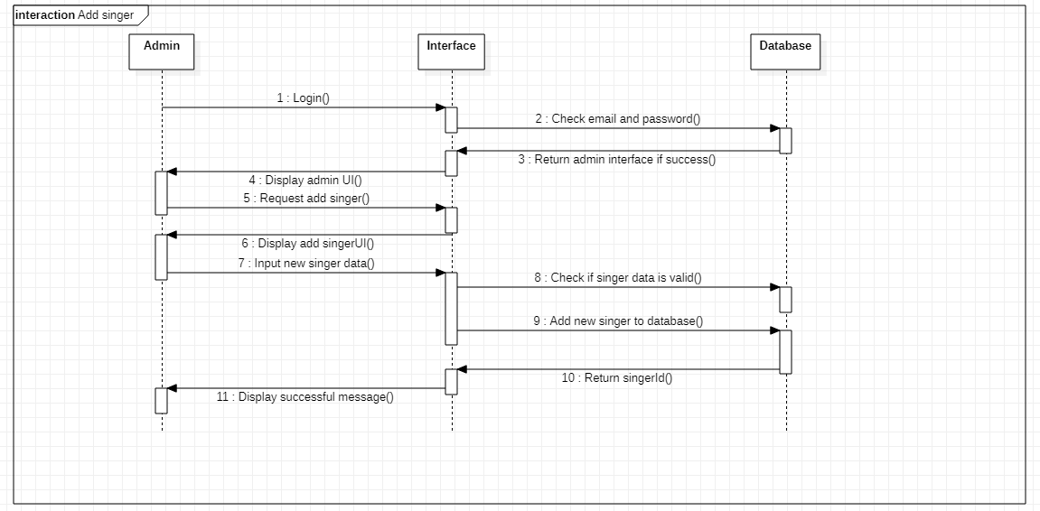

|  |  |
| --- | --- |
| **Author** | Lư Hán Luân |
| **Usecase Name** | Add singer (admin) |
| **Actor(s)** | Admin |
| **Description** | Admin add a new singer to database |
| **Pre-condition(s)** | * Admin has account with role admin. * Internet connection is stable. |
| **Basic Flow** | 1. Admin login to the system. 2. System validates login information. 3. Return login success. 4. Display admin UI. 5. Select singer tab and press “add”. 6. Display add singer interface. 7. Input new singer data. 8. Check if the input data is valid. 9. Add new singer to database. 10. Return new singerId to interface. 11. Display successfully message. |
| **Exception Flow** | 1.1 Return login fail message if admin login fail.  8.1 If the data is not valid, return add fail message. |

### Searching data function (user):

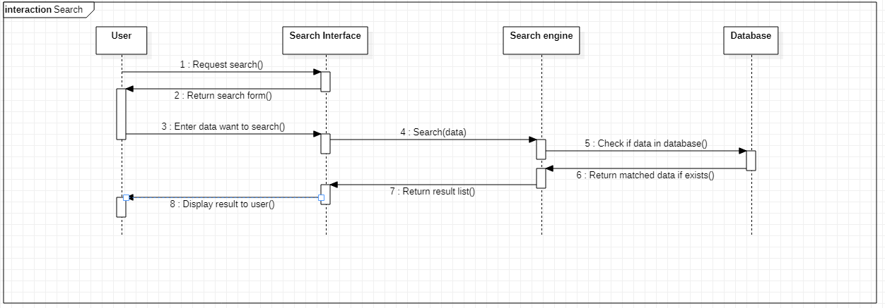

|  |  |
| --- | --- |
| **Author** | Lư Hán Luân |
| **Usecase Name** | Search data |
| **Actor(s)** | User |
| **Description** | User search information of song, albums, singers or musicians |
| **Pre-condition(s)** | * Internet connection is stable. |
| **Basic Flow** | 1. User find the search form. 2. Return search form to user. 3. User enter data to search. 4. Search data by search engine. 5. Check if data is valid in database. 6. Return matched data if data exists. 7. Return result list to interface. 8. Display result to user. |
| **Exception Flow** |  |

## Create playlist (user):

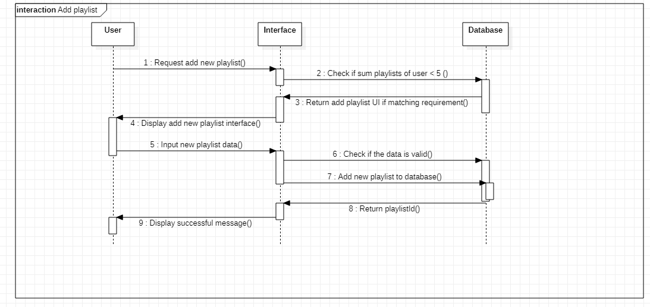

|  |  |
| --- | --- |
| **Author** | Lư Hán Luân |
| **Usecase Name** | Create playlist |
| **Actor(s)** | User |
| **Description** | User create a new playlist |
| **Pre-condition(s)** | * Internet connection is stable. * User is a VIP member |
| **Basic Flow** | 1. User requests to add a new playlist 2. Check if user has less than 5 playlists. 3. Return add playlist UI if matching requirement. 4. Display add new playlist interface to user. 5. User input the playlist data. 6. System check if data is valid. 7. Add new playlist to database. 8. Return playlistId to interface. 9. Display successful message to user. |
| **Exception Flow** | 2.1 Return add fail if user already has more or equal to 5 playlists.  6.1 If the data is not valid, return add fail message. |

## Login (User)

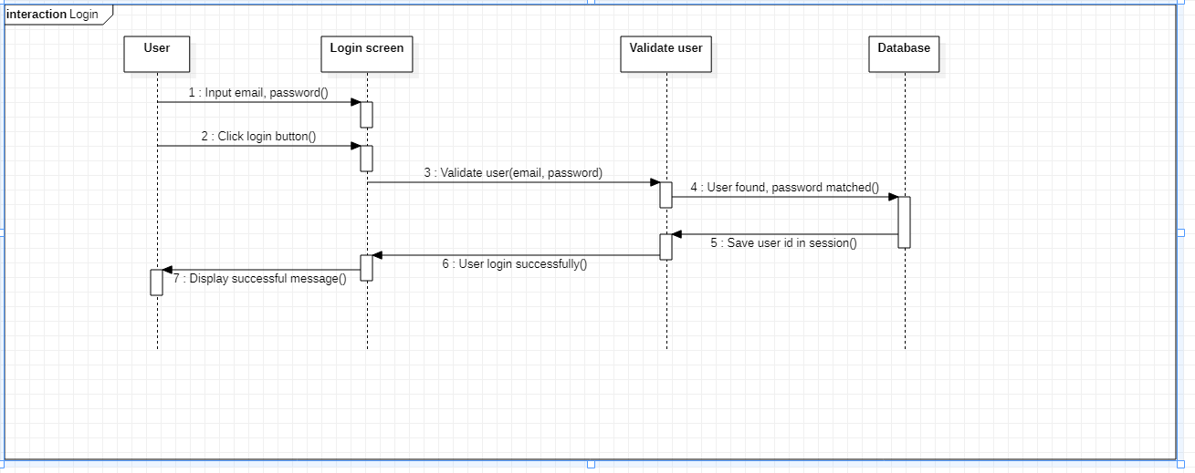

|  |  |
| --- | --- |
| **Author** | Lư Hán Luân |
| **Usecase Name** | Login |
| **Actor(s)** | User |
| **Description** | Admin add a new song to database |
| **Pre-condition(s)** | * User has account with user role. * Internet connection is stable. |
| **Basic Flow** | 1. User types email, password to login. 2. User clicks login button. 3. System validate the input information (email, password). 4. Check if email and password matched the data in database. 5. Save user id in session. 6. Notify that user login successfully. 7. Display login successful message to user. |
| **Exception Flow** | 3.1 Return login fail message if admin login fail. |

# **ENTITY RELATIONSHIP DIAGRAM**

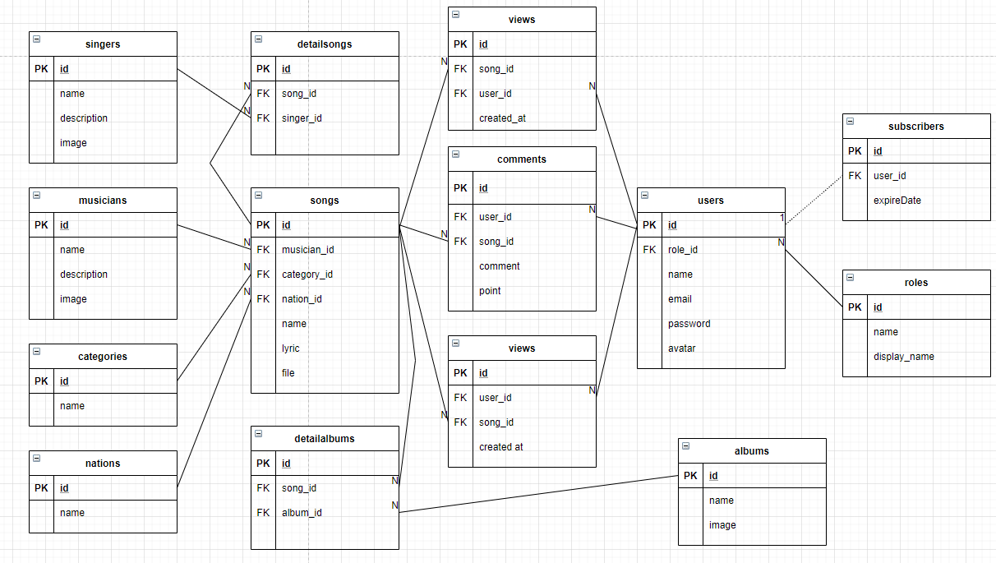

# **TABLE DESIGN**

## Table Users:

|  |  |  |  |  |  |  |
| --- | --- | --- | --- | --- | --- | --- |
| **Users** | | | | | | |
| **Field Name** | **Data Type** | **Null** | **Default Value** | **Key** | **Table-Field-Ref** | **Description** |
| id | bigint | No |  | PK | Identity | Stores user id |
| role_id | bigint | No |  | FK |  | Stores user role |
| name | Character varying (255) | No |  |  |  | Stores name of user |
| email | Character varying (255) | No |  | UNI |  | Stores user email |
| password | Character varying (255) | No |  |  |  | Stores user password |
| avatar | Character varying (255) | Yes | true |  |  | Stores avatar image of user |

## Table Roles:

|  |  |  |  |  |  |  |
| --- | --- | --- | --- | --- | --- | --- |
| **Roles** | | | | | | |
| **Field Name** | **Data Type** | **Null** | **Default Value** | **Key** | **Table-Field-Ref** | **Description** |
| id | bigint | No |  | PK | Identity | Stores role id |
| name | Character varying (255) | No |  | UNI |  | Stores role name |
| display_name | Character varying (255) | No |  |  |  | Stores role display name |

## Table Songs:

|  |  |  |  |  |  |  |
| --- | --- | --- | --- | --- | --- | --- |
| **Tours** | | | | | | |
| **Field Name** | **Data Type** | **Null** | **Default Value** | **Key** | **Table-Field-Ref** | **Description** |
| id | bigint | No |  | PK | Identity | Stores song id |
| musician_id | bigint | No |  | FK |  | Stores musician id |
| category_id | bigint | No |  | FK |  | Stores category id |
| nation_id | bigint | No |  | FK |  | Stores nation id |
| name | Character varying (255) | No |  |  |  | Stores name of song |
| lyric | Character varying (15000) | No |  |  |  | Stores song’s lyric |
| file | Character varying (255) | No |  |  |  | Stores file of song |

## Table Categories:

|  |  |  |  |  |  |  |
| --- | --- | --- | --- | --- | --- | --- |
| **TourTypes** | | | | | | |
| **Field Name** | **Data Type** | **Null** | **Default Value** | **Key** | **Table-Field-Ref** | **Description** |
| ID | bigint | No |  | PK | Identity | Stores category id |
| Name | Character varying (255) | No |  |  |  | Stores category name |

## Table Singers:

|  |  |  |  |  |  |  |
| --- | --- | --- | --- | --- | --- | --- |
| **TourLocations** | | | | | | |
| **Field Name** | **Data Type** | **Null** | **Default Value** | **Key** | **Table-Field-Ref** | **Description** |
| id | bigint | No |  | PK | Identity | Stores singer id |
| name | Character varying (255) | No |  |  |  | Stores singer name |
| description | Character varying (15000) | Yes |  |  |  | Stores singer description |
| image | Character varying (255) | Yes |  |  |  | Stores singer image |

## Table Musicians:

|  |  |  |  |  |  |  |
| --- | --- | --- | --- | --- | --- | --- |
| **TourImages** | | | | | | |
| **Field Name** | **Data Type** | **Null** | **Default Value** | **Key** | **Table-Field-Ref** | **Description** |
| id | bigint | No |  | PK | Identity | Stores musician id |
| name | Character varying (255) | No |  |  |  | Stores musician name |
| description | Character varying (15000) | Yes |  |  |  | Stores musician description |
| image | Character varying (255) | Yes |  |  |  | Stores musician image |

## Table Subcribers:

|  |  |  |  |  |  |  |
| --- | --- | --- | --- | --- | --- | --- |
| **ReviewTours** | | | | | | |
| **Field Name** | **Data Type** | **Null** | **Default Value** | **Key** | **Table-Field-Ref** | **Description** |
| id | bigint | No |  | PK | Identity | Stores subcriber id |
| user_id | bigint | No |  | FK |  | Stores user id |
| expireDate | dateTime | No |  |  |  | Stores expire date of subcriber |

## Table Comments:

|  |  |  |  |  |  |  |
| --- | --- | --- | --- | --- | --- | --- |
| **ReviewGuides** | | | | | | |
| **Field Name** | **Data Type** | **Null** | **Default Value** | **Key** | **Table-Field-Ref** | **Description** |
| id | bigint | No |  | PK | Identity | Stores comment id |
| user_id | bigint | No |  | FK |  | Stores user id |
| song_id | bigint | No |  | FK |  | Stores song id |
| comment | Character varying (255) | No |  |  |  | Stores comment |
| point | double | No |  |  |  | Stores point |

## Table detailsongs:

|  |  |  |  |  |  |  |
| --- | --- | --- | --- | --- | --- | --- |
| **Locations** | | | | | | |
| **Field Name** | **Data Type** | **Null** | **Default Value** | **Key** | **Table-Field-Ref** | **Description** |
| id | bigint | No |  | PK | Identity | Stores detail song id |
| song_id | bigint | No |  | FK |  | Stores song id |
| singer_id | bigint | No |  | FK |  | Stores singer id |

## Table views:

|  |  |  |  |  |  |  |
| --- | --- | --- | --- | --- | --- | --- |
| **Locations** | | | | | | |
| **Field Name** | **Data Type** | **Null** | **Default Value** | **Key** | **Table-Field-Ref** | **Description** |
| id | bigint | No |  | PK | Identity | Stores view id |
| user_id | bigint | No |  | FK |  | Stores user id |
| song_id | bigint | No |  | FK |  | Stores song id |
| created_at | dateTime | No |  |  |  | Stores created time of view |

## Table nations:

|  |  |  |  |  |  |  |
| --- | --- | --- | --- | --- | --- | --- |
| **Guides** | | | | | | |
| **Field Name** | **Data Type** | **Null** | **Default Value** | **Key** | **Table-Field-Ref** | **Description** |
| id | bigint | No |  | PK | Identity | Stores guide id |
| name | Character varying  (255) | No |  |  |  | Stores guide description |

## Table Views:

|  |  |  |  |  |  |  |
| --- | --- | --- | --- | --- | --- | --- |
| **Bookings** | | | | | | |
| **Field Name** | **Data Type** | **Null** | **Default Value** | **Key** | **Table-Field-Ref** | **Description** |
| ID | bigint | No |  | PK | Identity | Stores playlist id |
| user_id | bigint | No |  | FK |  | Stores user id |
| song_id | bigint | No |  | FK |  | Stores song id |
| created_at | DateTime | No |  |  |  | Store date created view |

## Table detailplaylists:

|  |  |  |  |  |  |  |
| --- | --- | --- | --- | --- | --- | --- |
| **AuthenticationProviders** | | | | | | |
| **Field Name** | **Data Type** | **Null** | **Default Value** | **Key** | **Table-Field-Ref** | **Description** |
| id | bigint | No |  | PK | Identity | Stores detail playlist id |
| song_id | bigint | No |  | FK |  | Stores song id |
| playlist_id | bigint | No |  | FK |  | Stores playlist id |

## Table albums:

|  |  |  |  |  |  |  |
| --- | --- | --- | --- | --- | --- | --- |
| **AuthenticationProviders** | | | | | | |
| **Field Name** | **Data Type** | **Null** | **Default Value** | **Key** | **Table-Field-Ref** | **Description** |
| id | bigint | No |  | PK | Identity | Stores album id |
| name | Character varying  (255) | No |  | FK |  | Stores album name |
| image | Character varying  (255) | No |  | FK |  | Stores album image |

## Table detailalbums:

|  |  |  |  |  |  |  |
| --- | --- | --- | --- | --- | --- | --- |
| **AuthenticationProviders** | | | | | | |
| **Field Name** | **Data Type** | **Null** | **Default Value** | **Key** | **Table-Field-Ref** | **Description** |
| id | bigint | No |  | PK | Identity | Stores detail album id |
| song_id | bigint | No |  | FK |  | Stores song id |
| album_id | bigint | No |  | FK |  | Stores album id |

# **FLOWCHART DIAGRAM**

1. 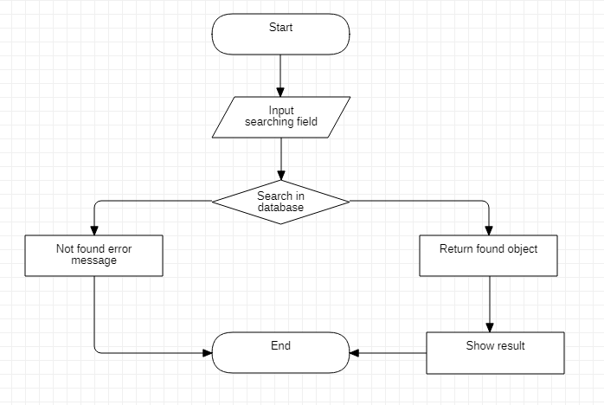Search
2. Register (user)

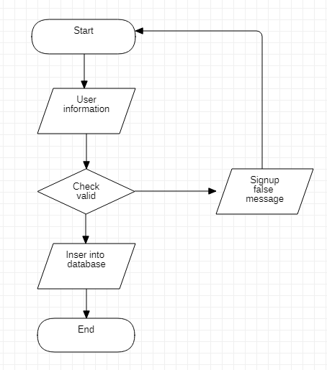

1. Login (user)

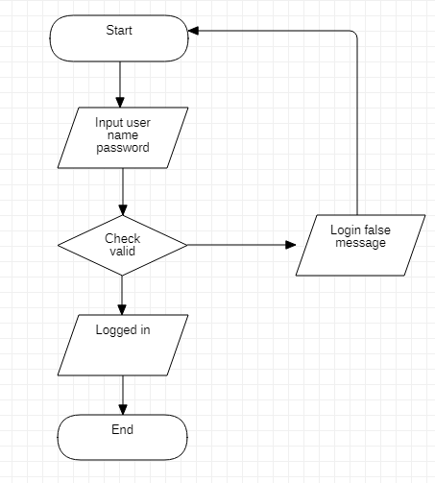

1. Login (admin)



# **SITEMAP**

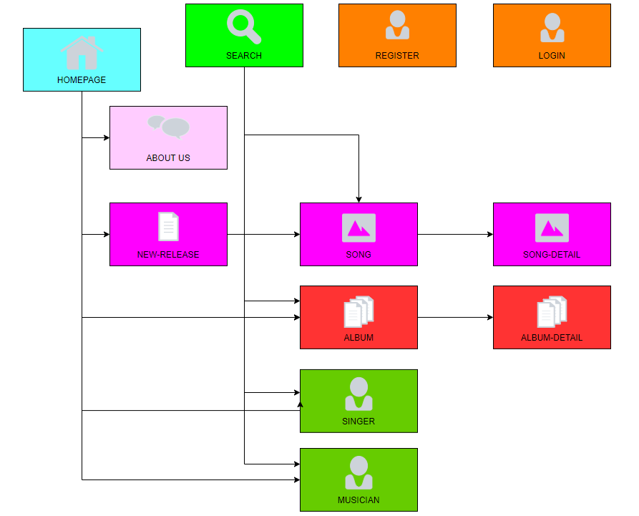

# **TASK SHEET REVIEW 2**

|  |  |  |  |  |  |  |  |
| --- | --- | --- | --- | --- | --- | --- | --- |
| **Project Ref. No.:**  **TRAVEL ToVN** | | **Project Title:** | **Activity Plan Prepared By:** | **Date of Preparation of Activity Plan:** | | | |
| **Sr.No.** | **Task** | **Actual Start Date** | **Actual Days** | **Team Mate Names** | **Status** |
| 1 | Usecase + Sequence Diagram | **Funky Fruit Music** | Lư Hán Luân | 22/07/2020 | 1 | Lư Hán Luân | 100% |
| 2 | ERD (Entity Relationship Diagram) | 22/07/2020 | 1 | Châu Đức Thịnh | 100% |
| 3 | Flowchart + Sitemap | 22/07/2020 | 1 | Đào Nguyễn Duy Khang | 100% |

|  |  |
| --- | --- |
| **Date: 13/08/2020** | |
| Signature of Instructor:  **MR. NGÔ PHƯỚC NGUYÊN** | Signature of Team Leader:  **LƯ HÁN LUÂN** |

# **REVIEW 3**

## **Admin:**

### Login:

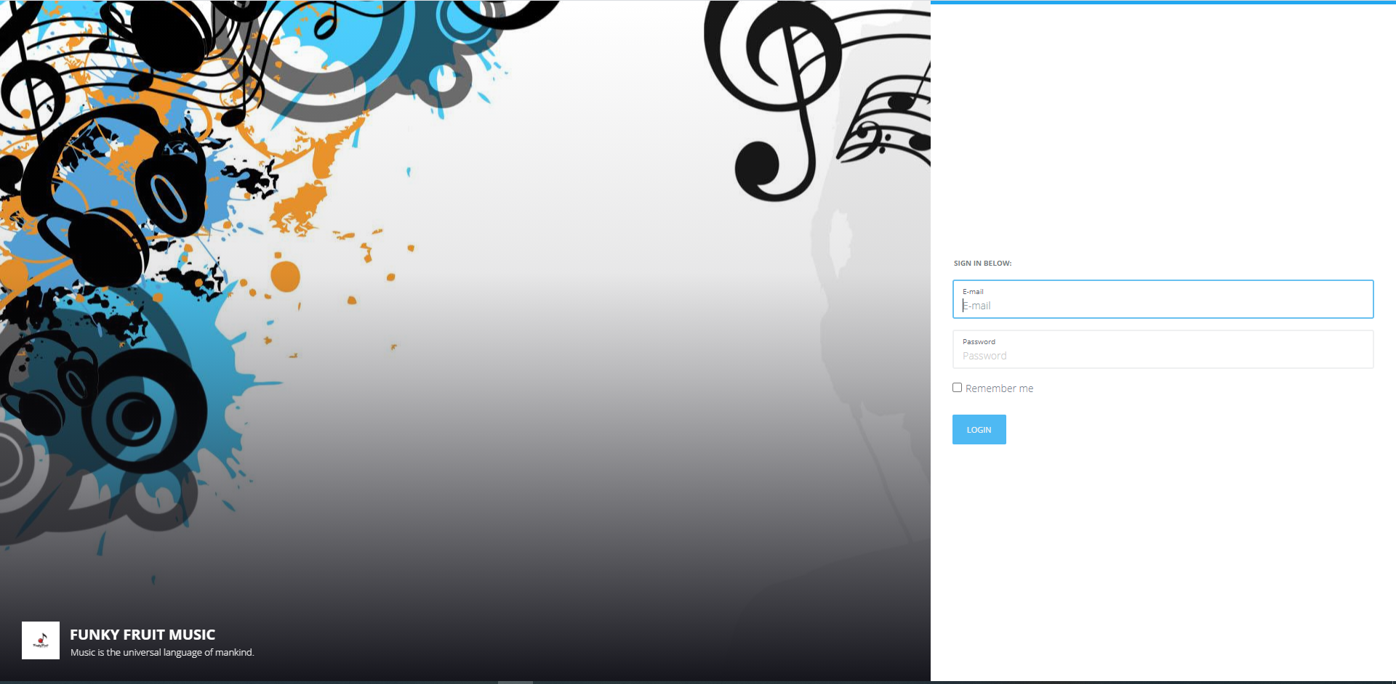

### Dashboard:

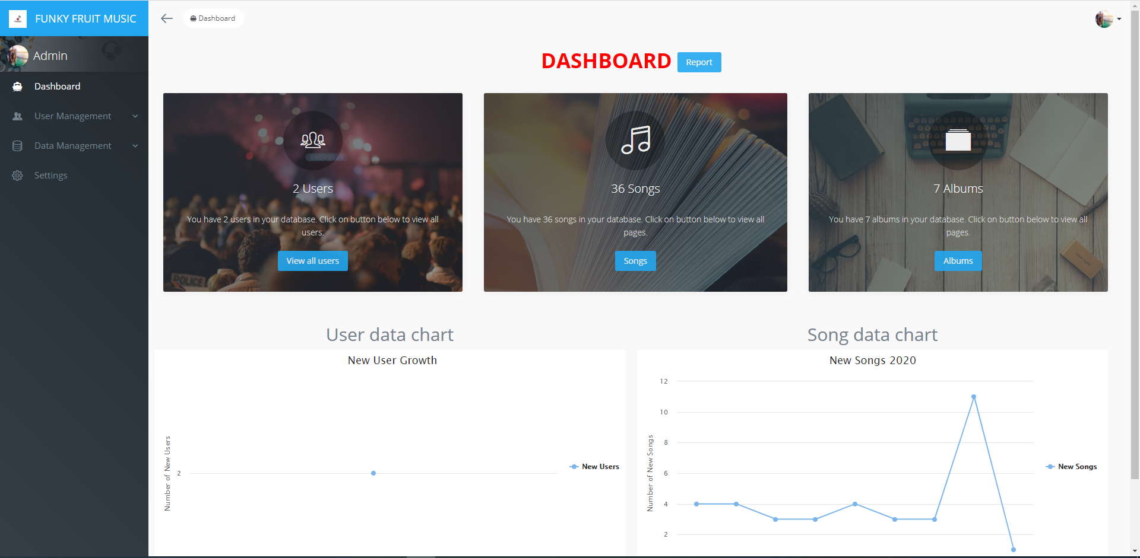

### Role:

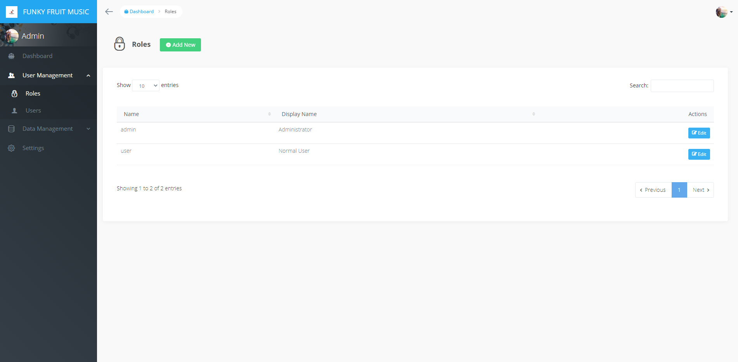

### User:

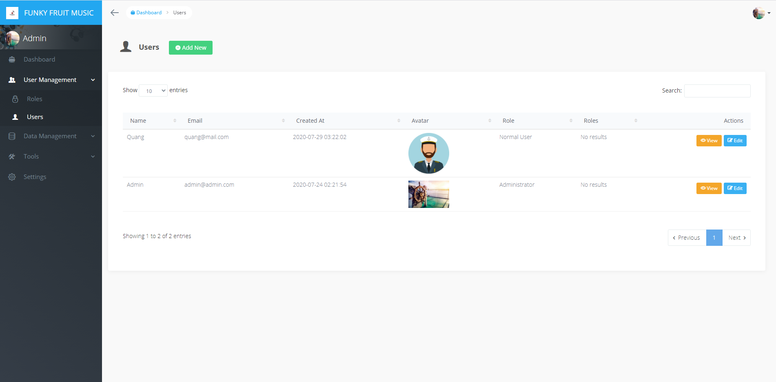

### User (Add new):

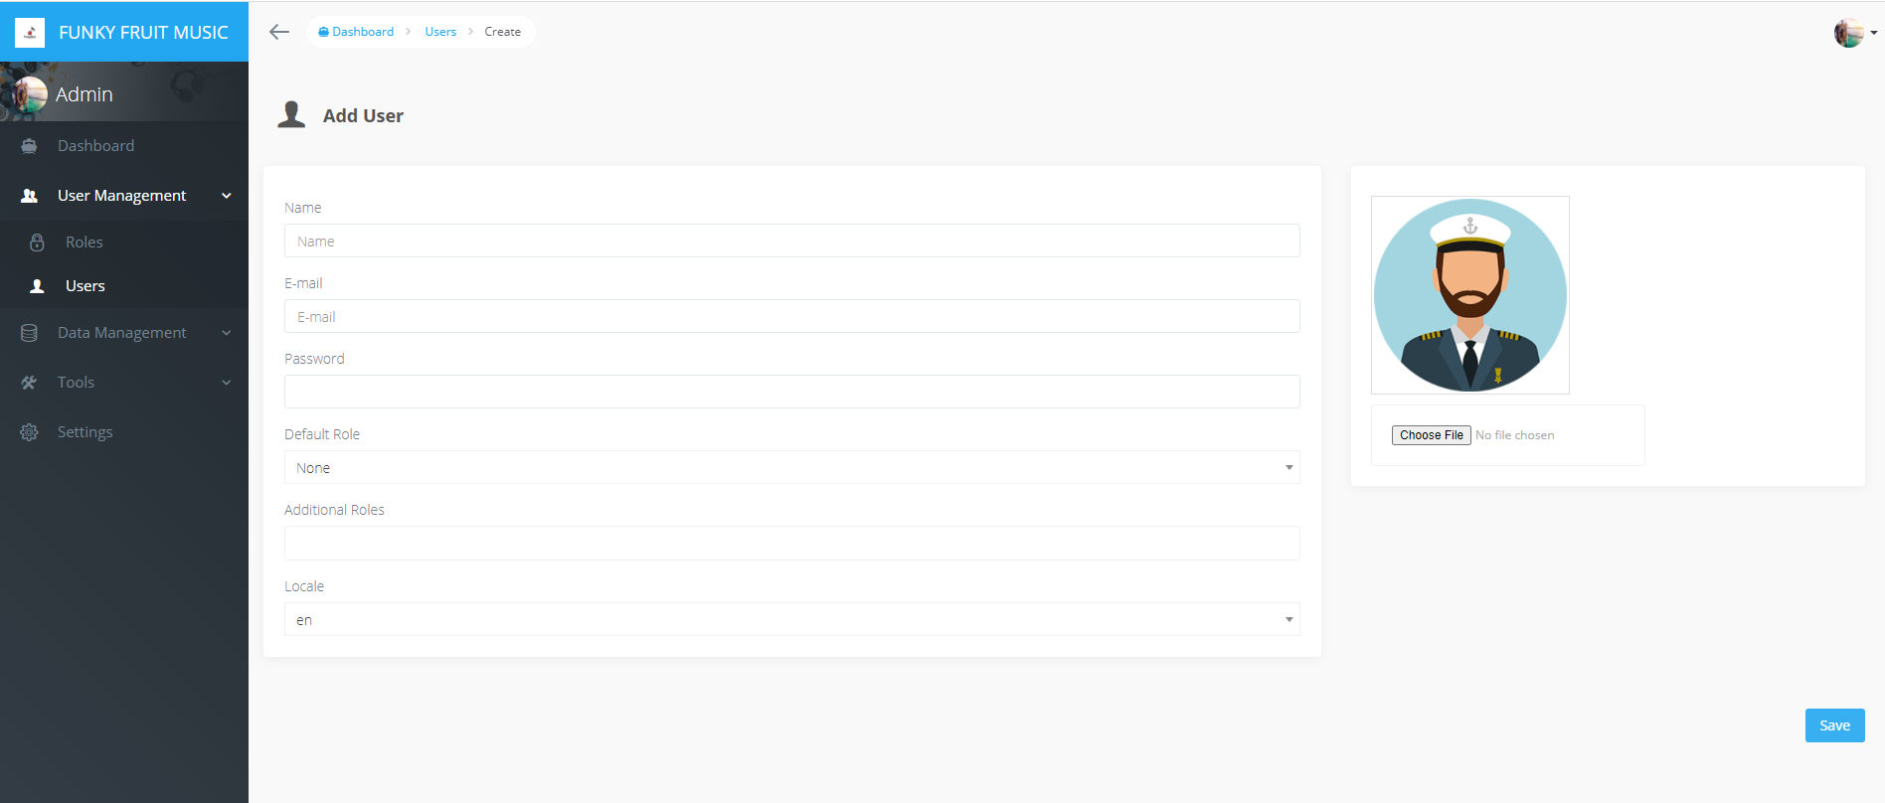

### Nations:

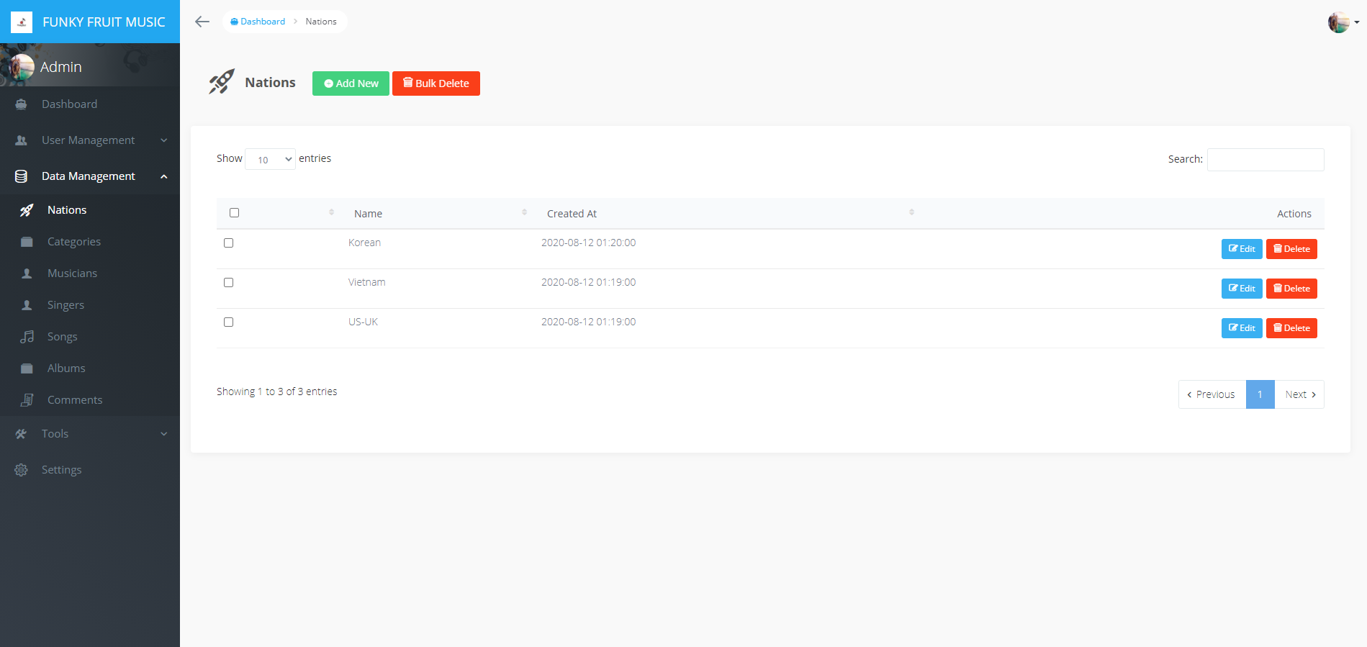

### Categories:

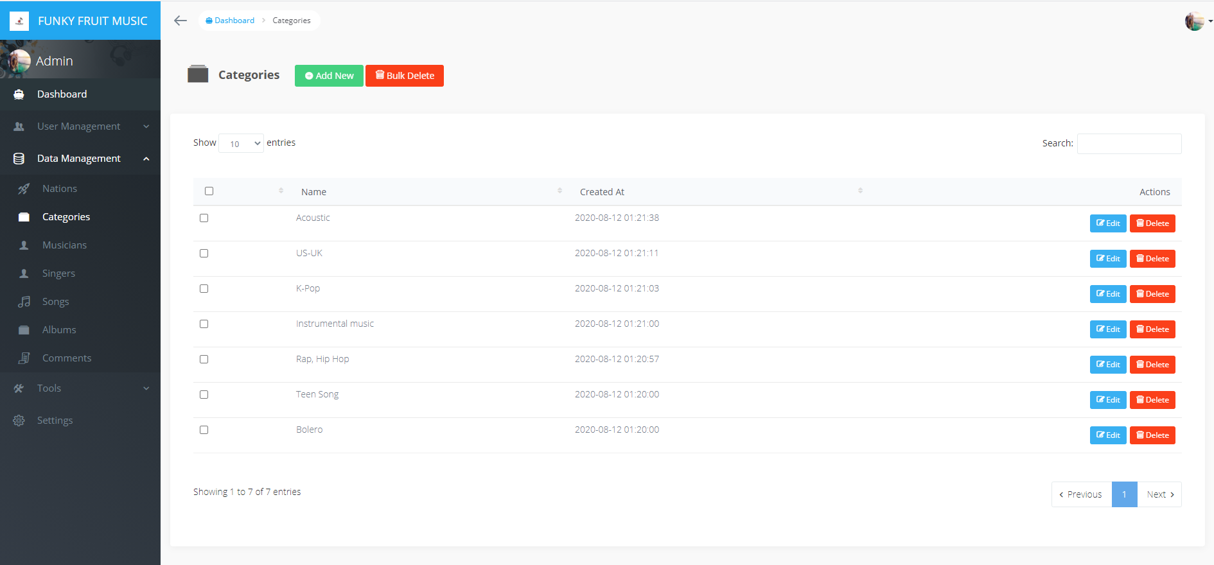

### Musicians:

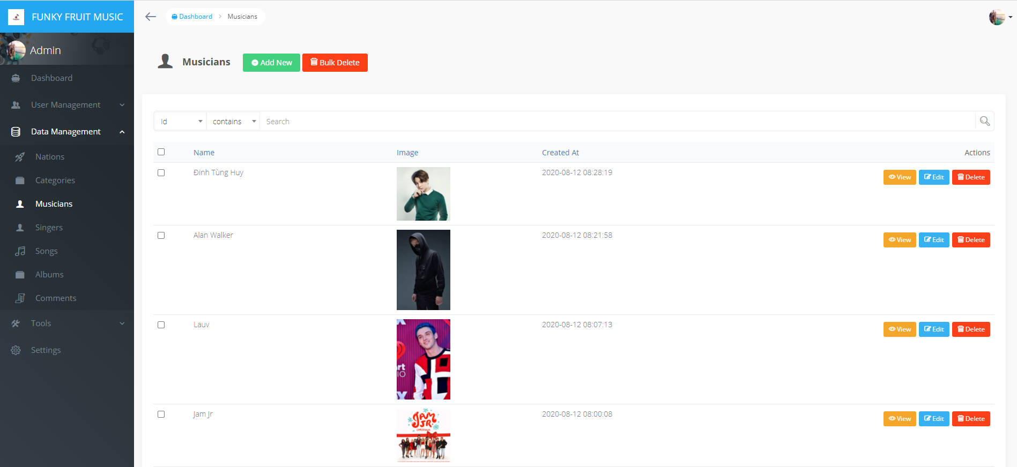

### Musicians (view):

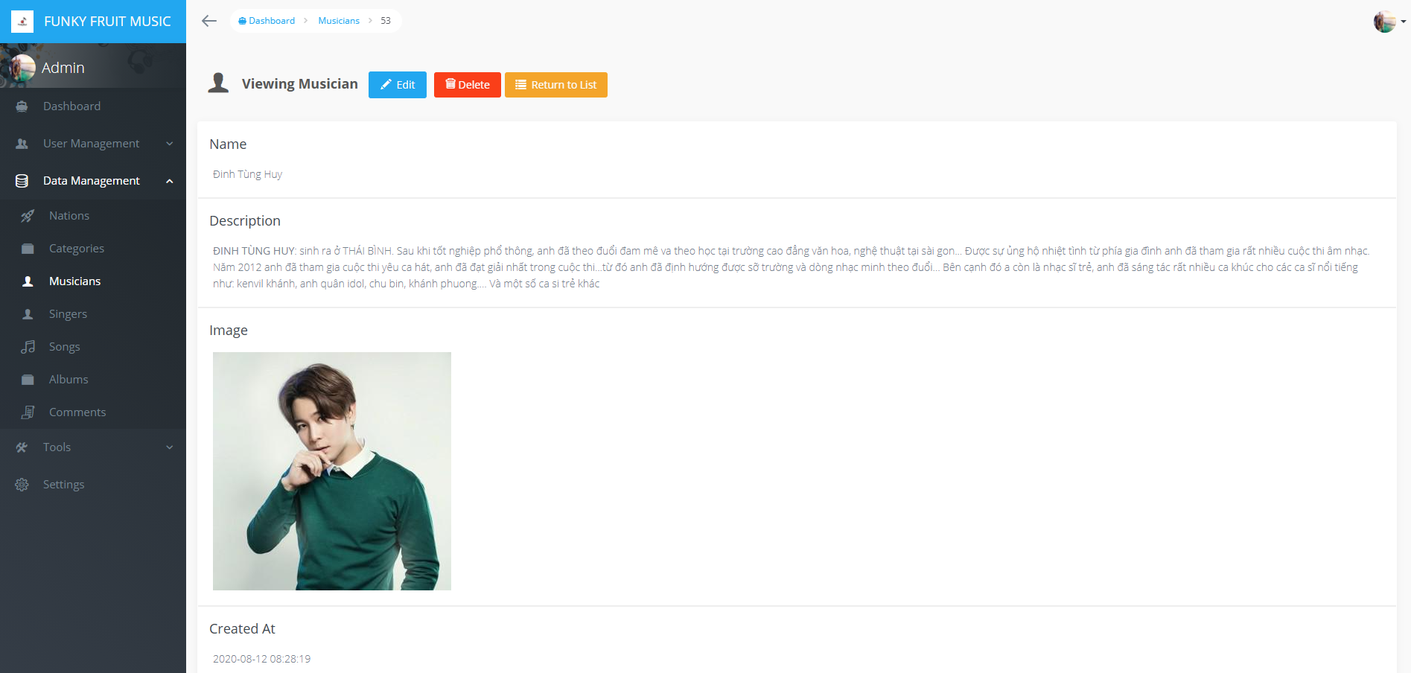

### Musicians (edit):

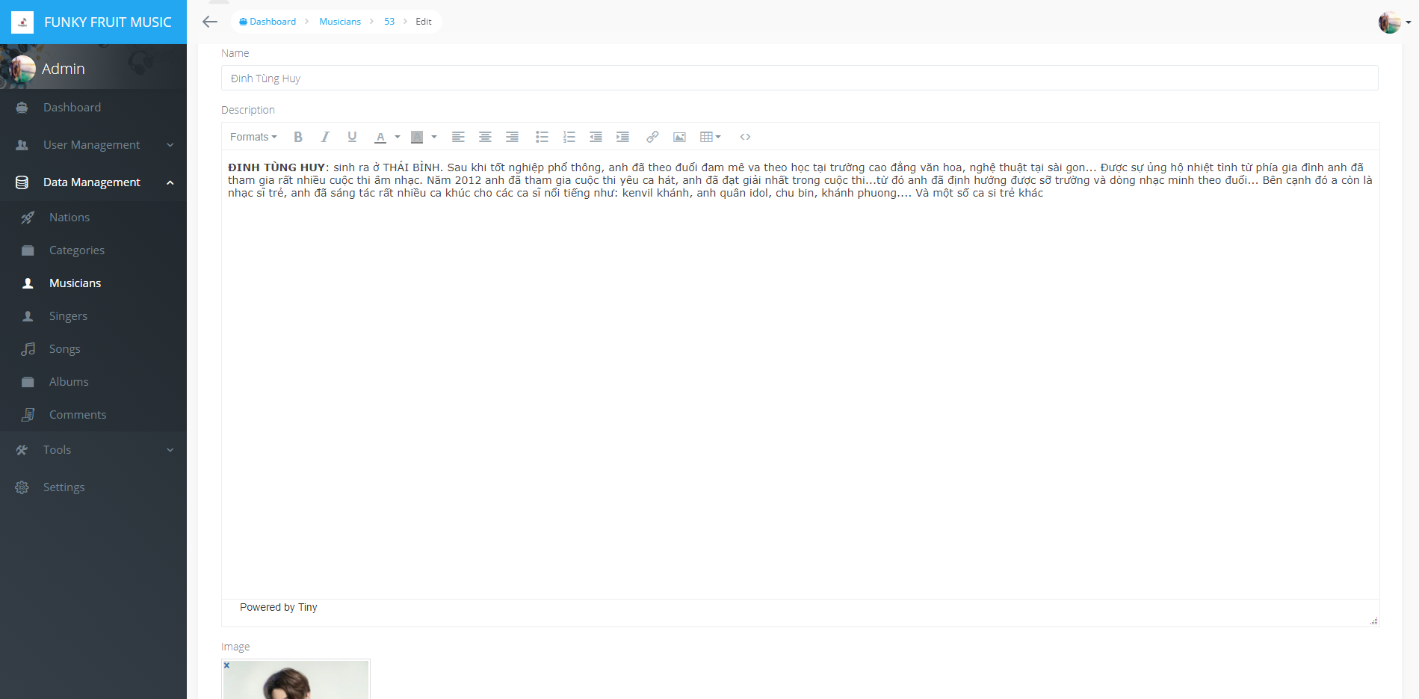

### Singers:

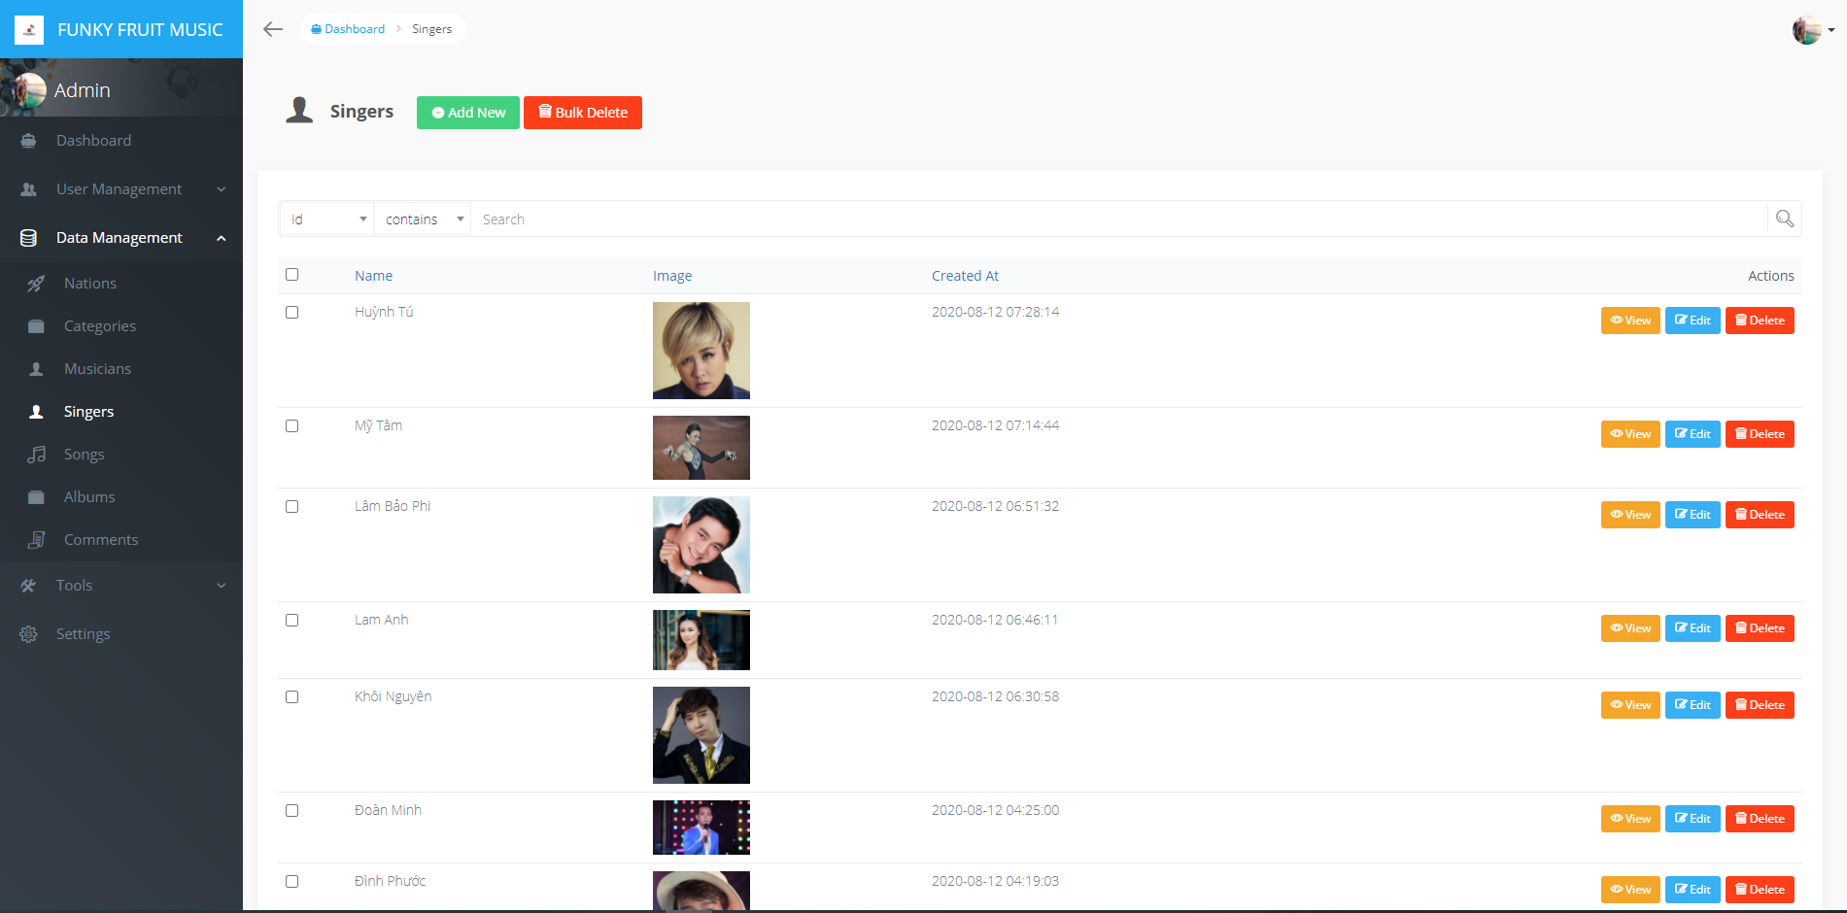

### Songs:

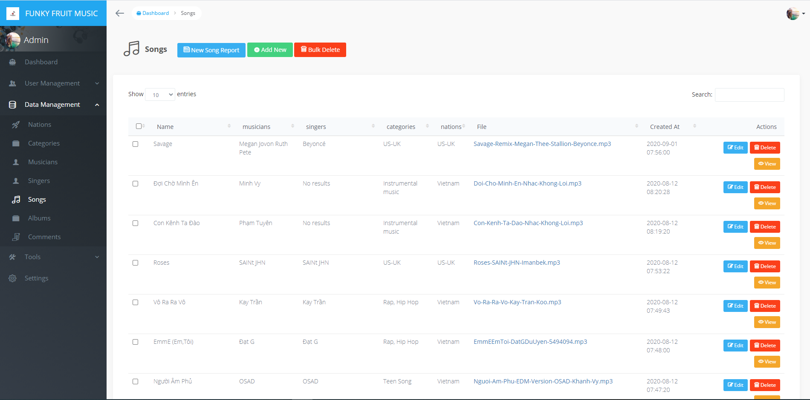

### Songs (view):

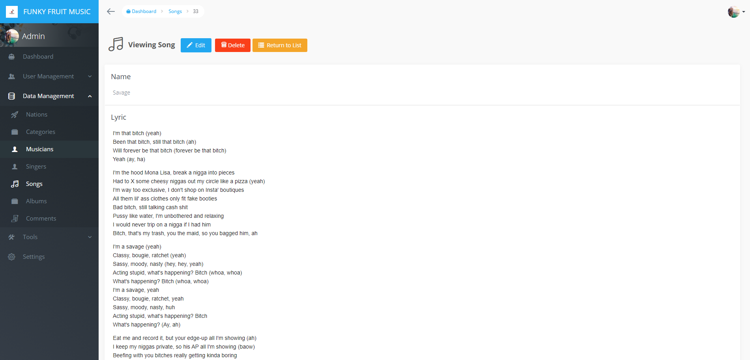 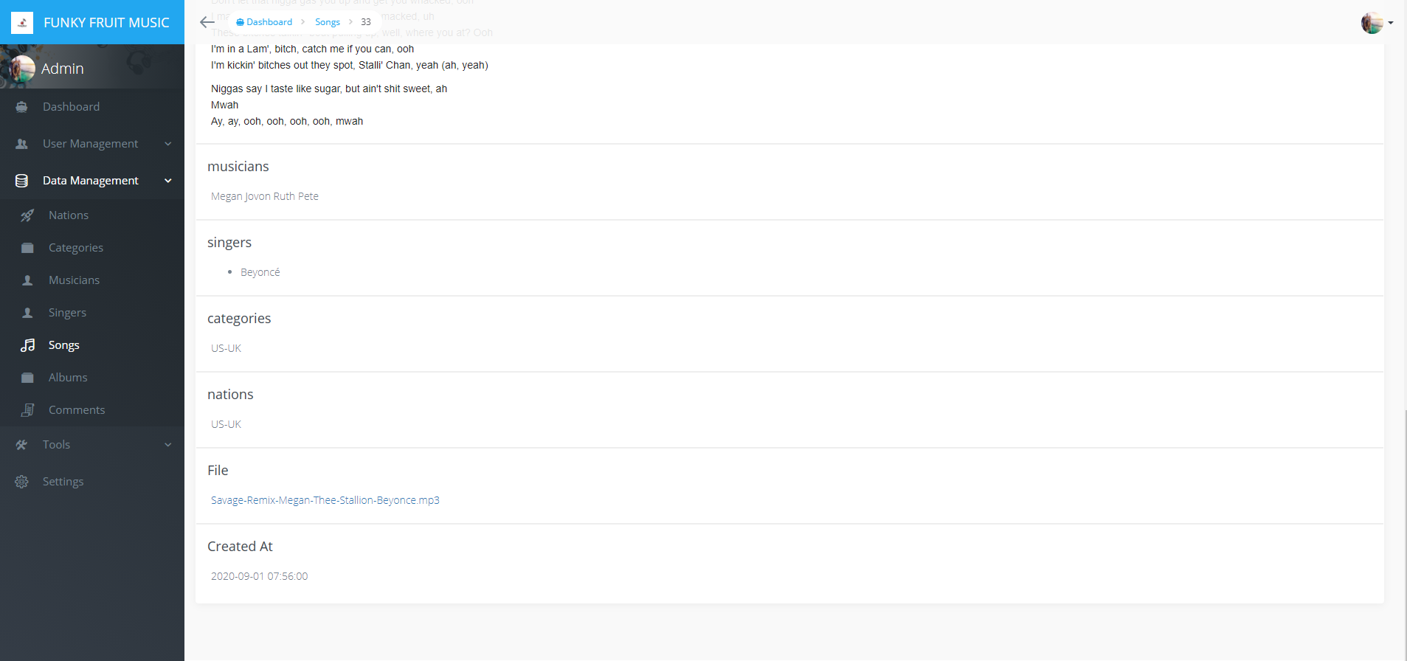

### Songs (edit):

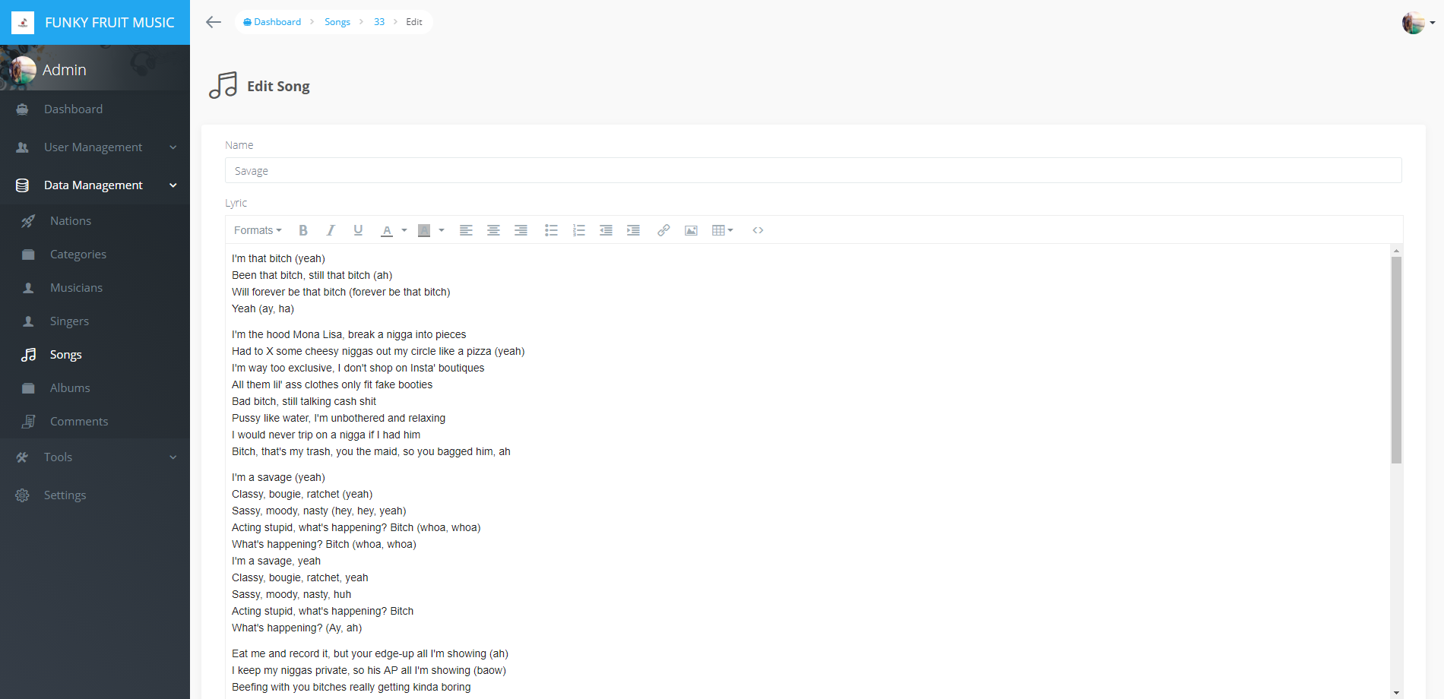



### Albums:

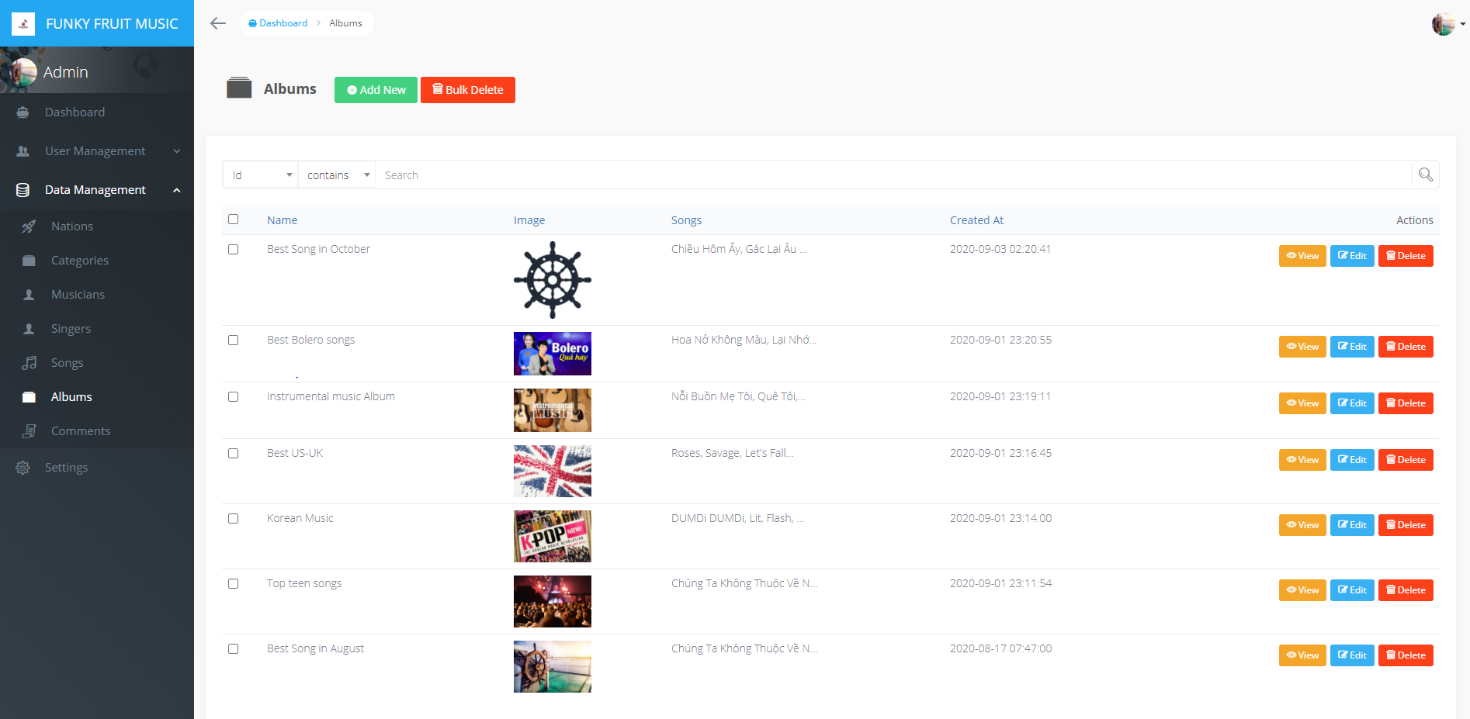

### Comments:

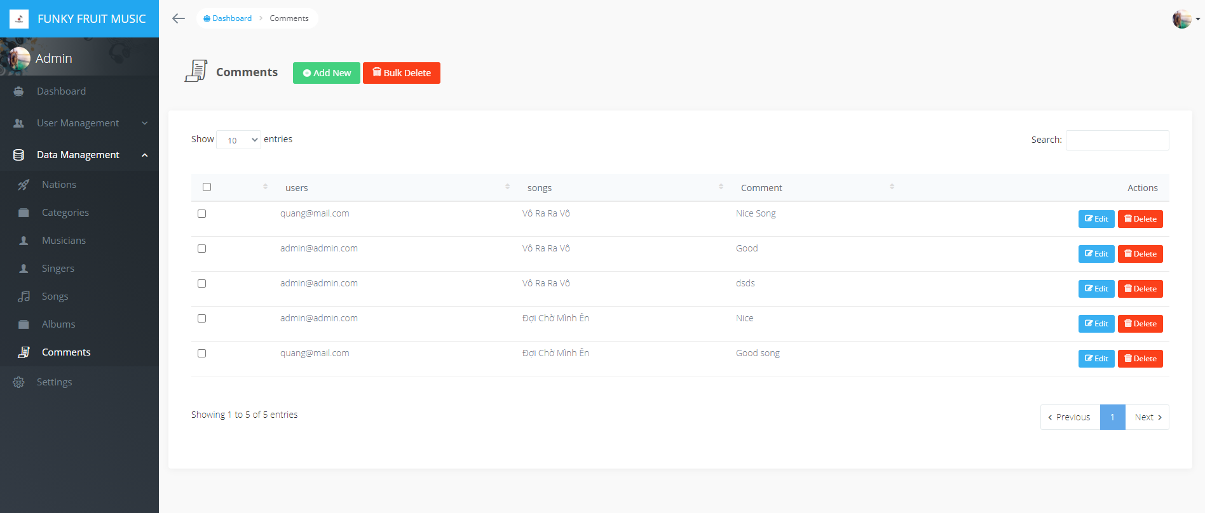

### Settings:

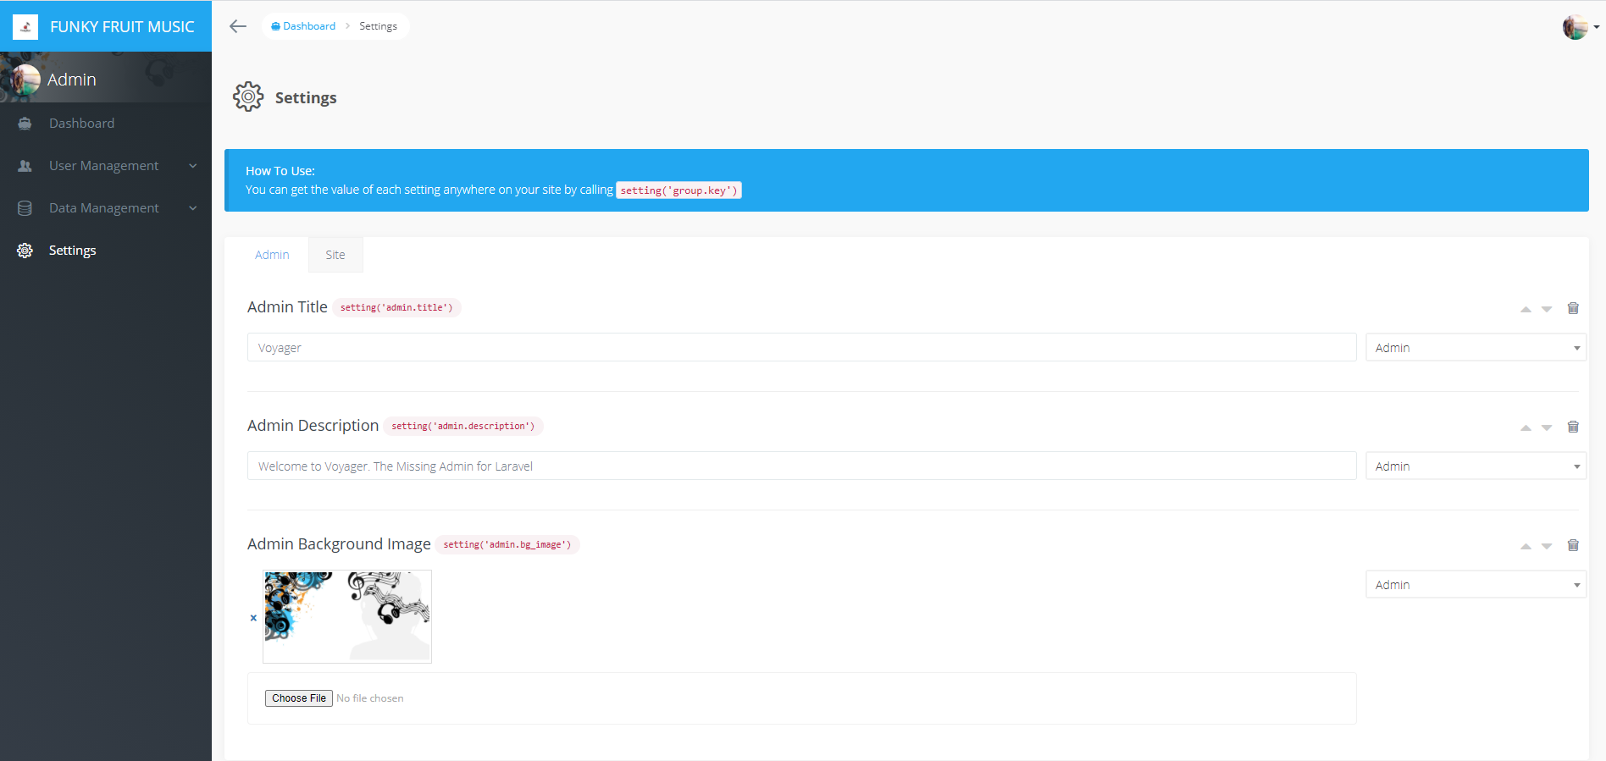

## **User:**

### Homepage:

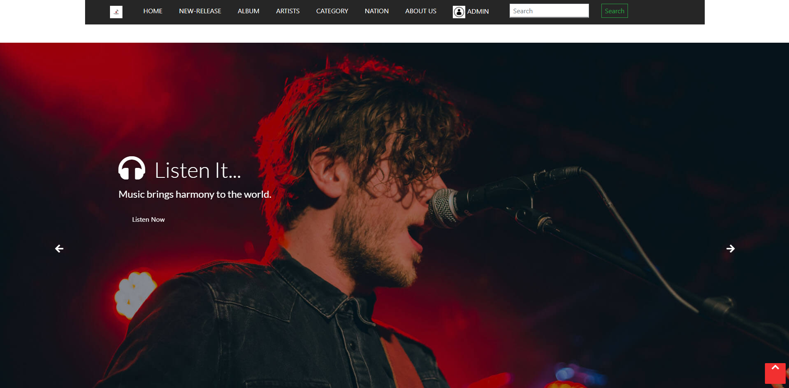

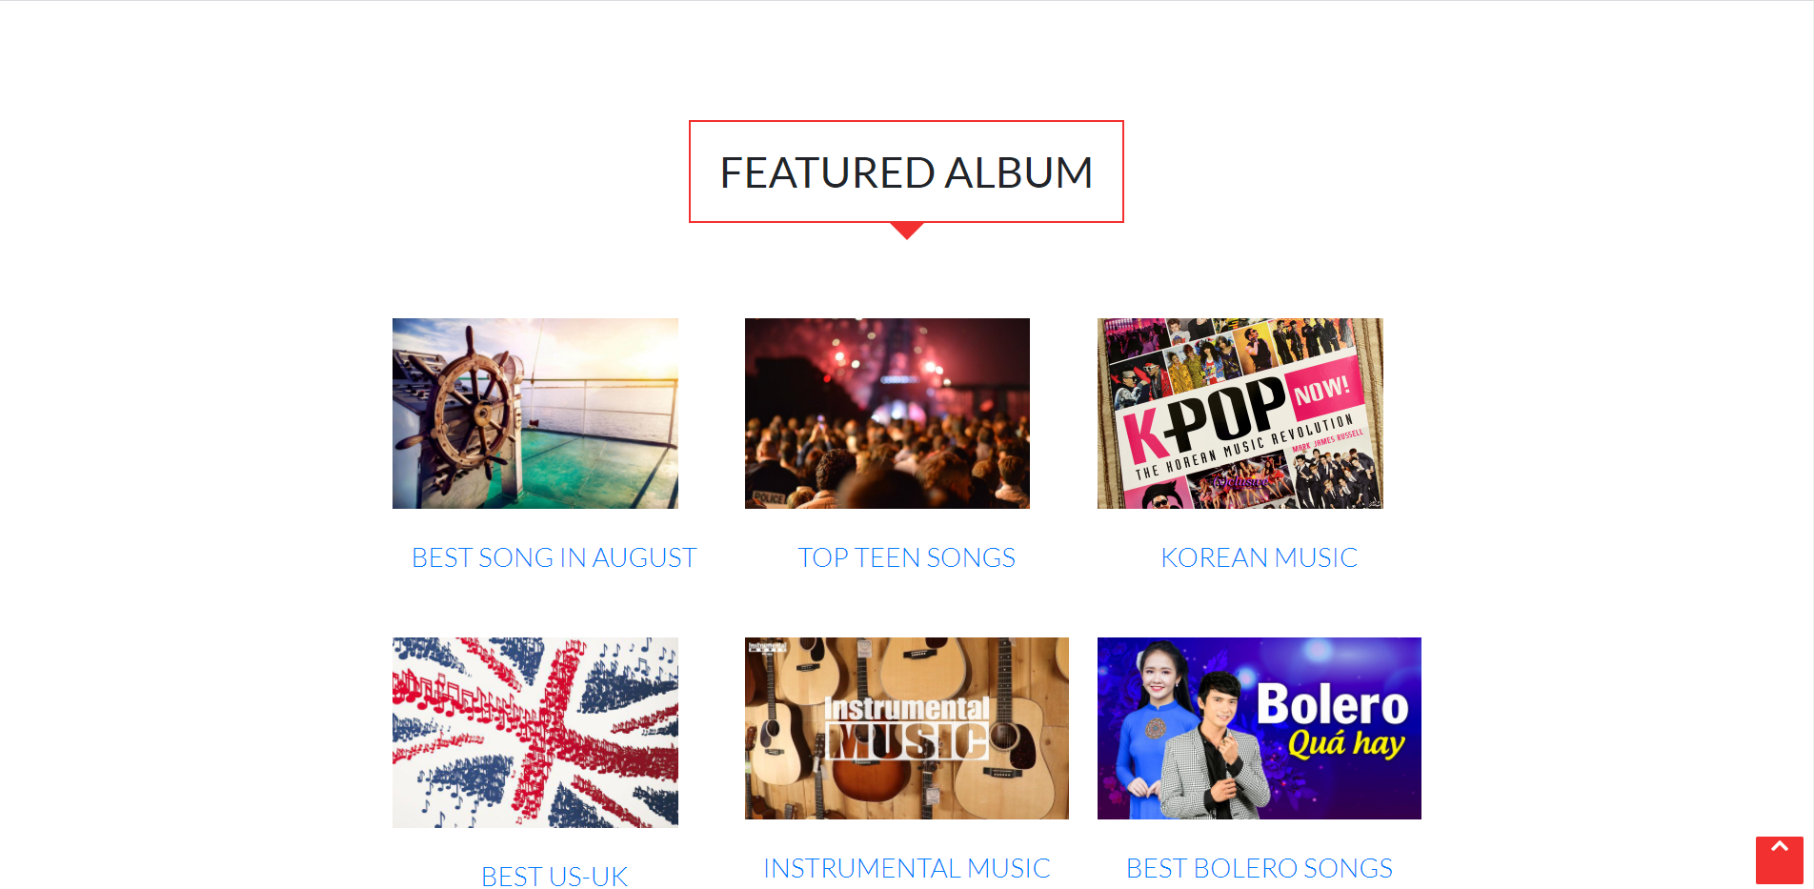

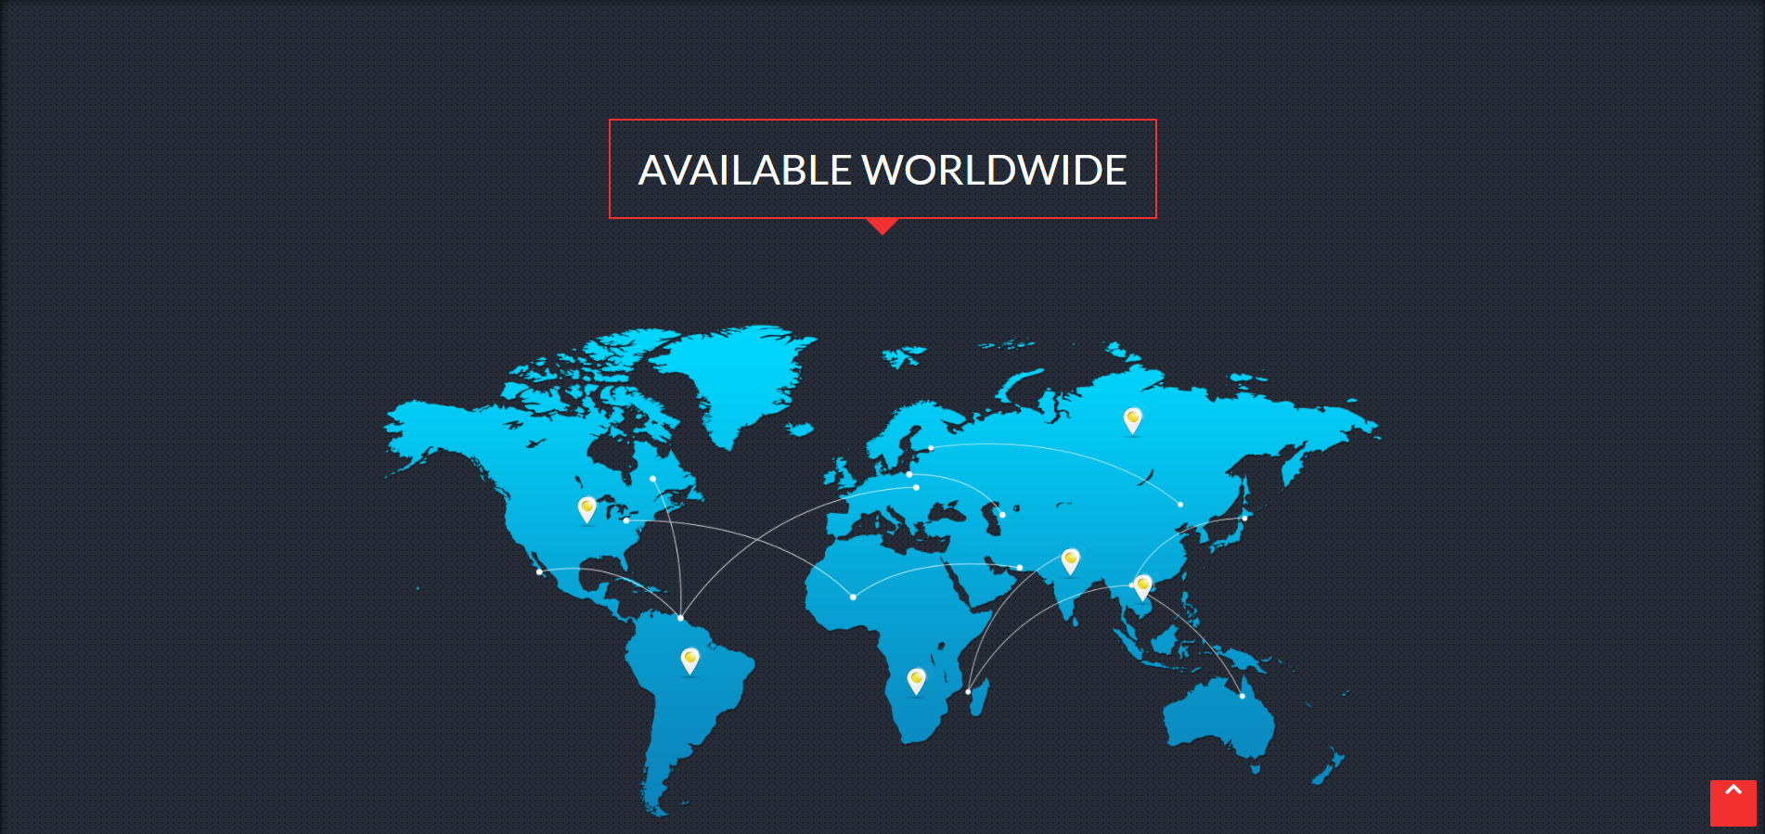

### New-release:

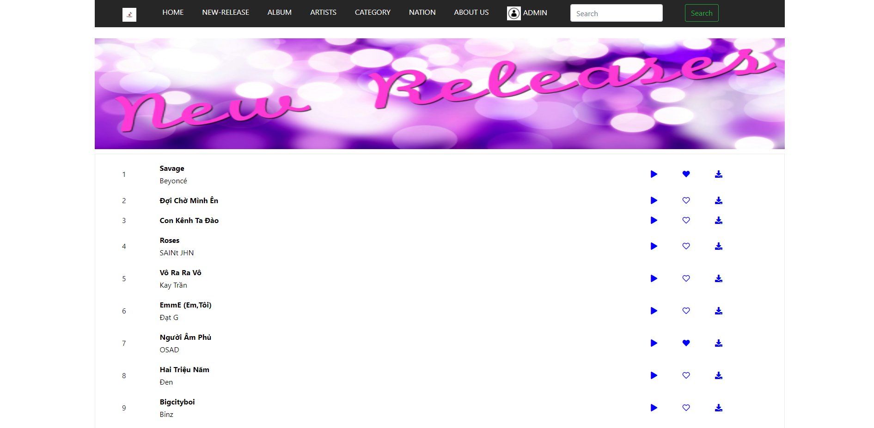

### Song:

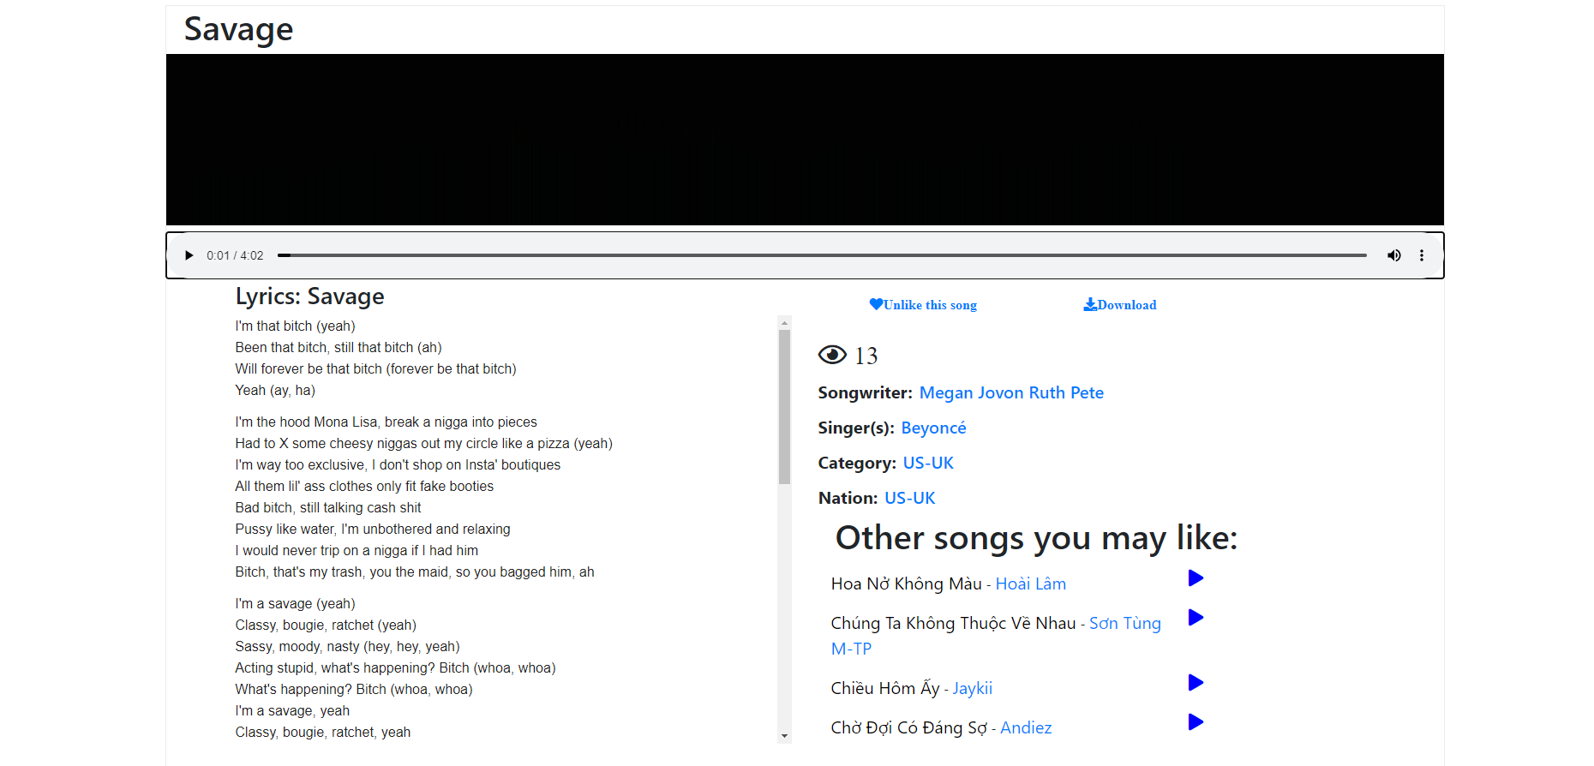

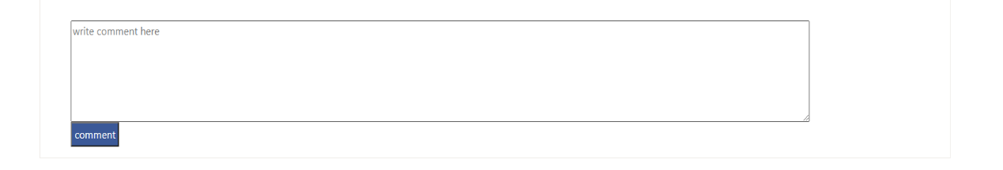

### Albums:

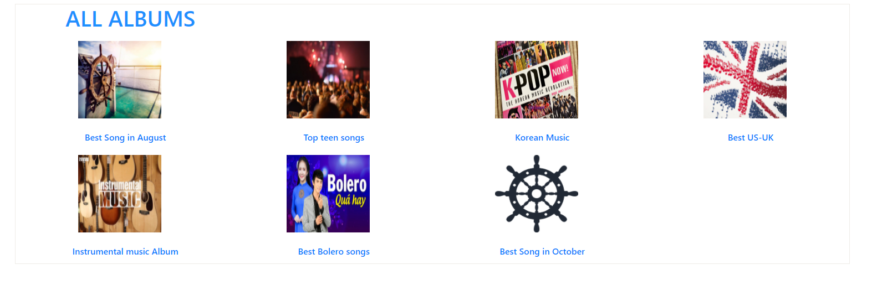

### Album-detail:

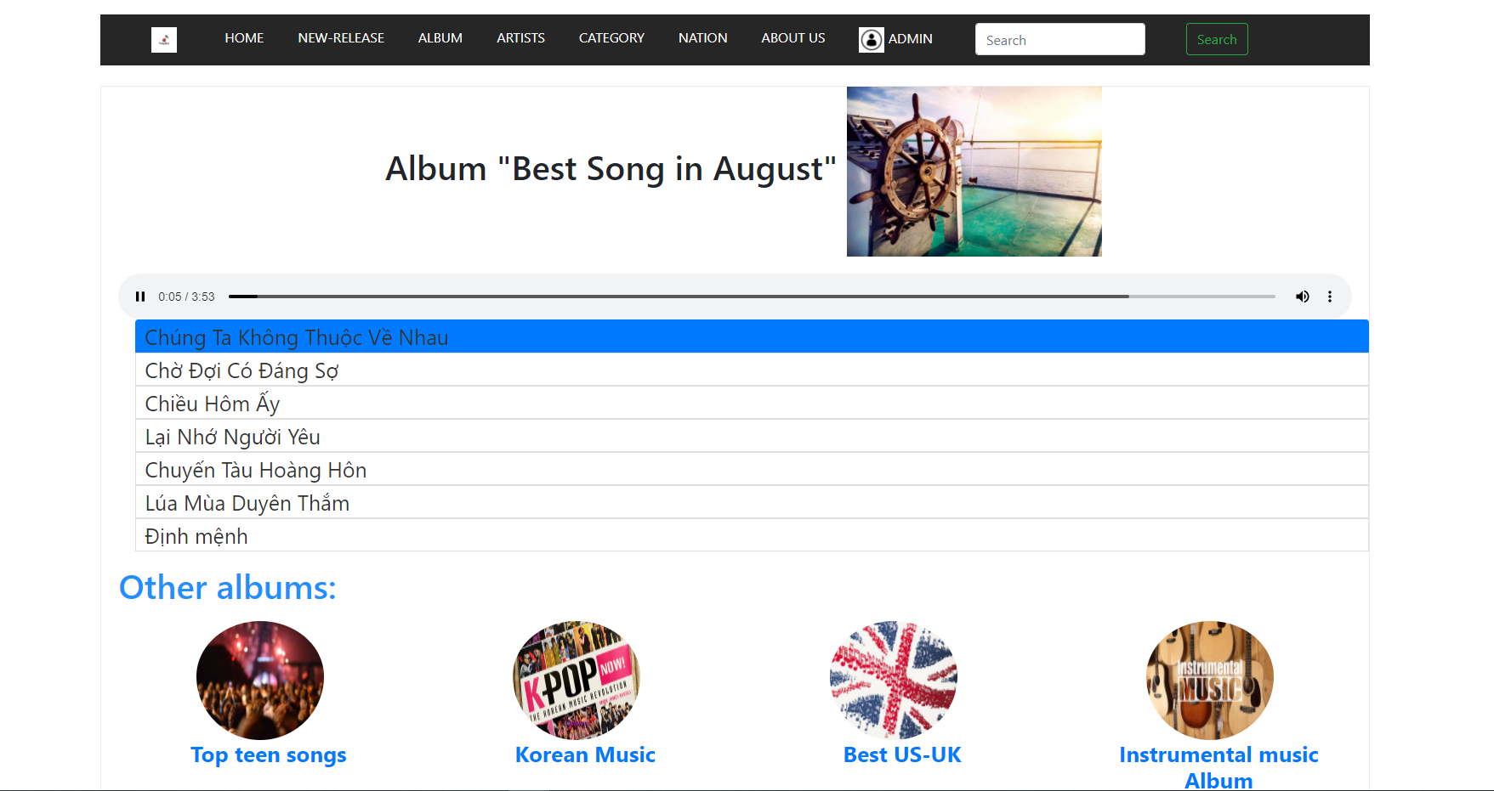

### Singers:

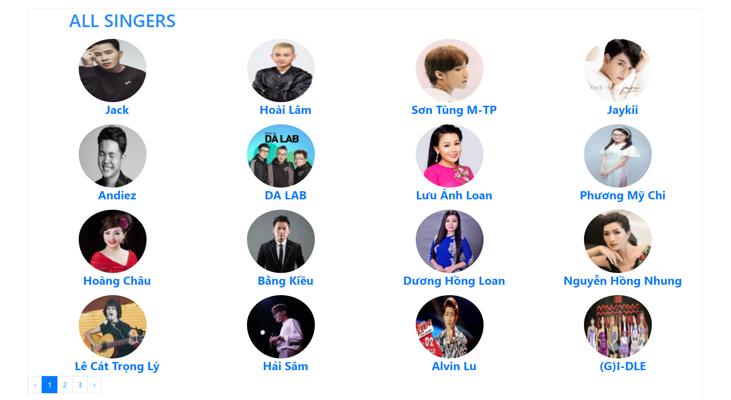

### Singer-detail:

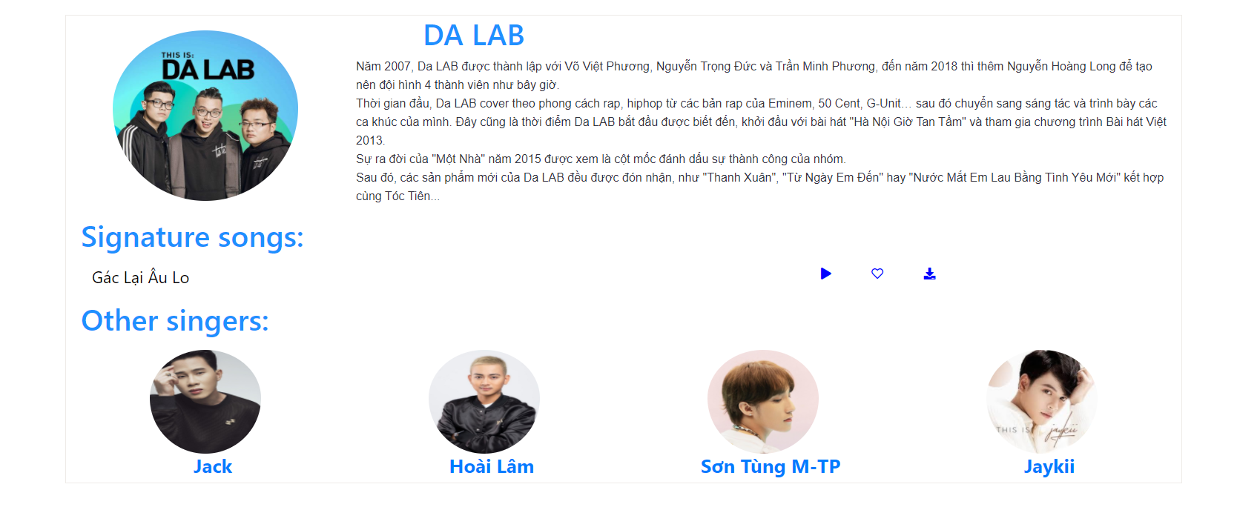

### Musicians:

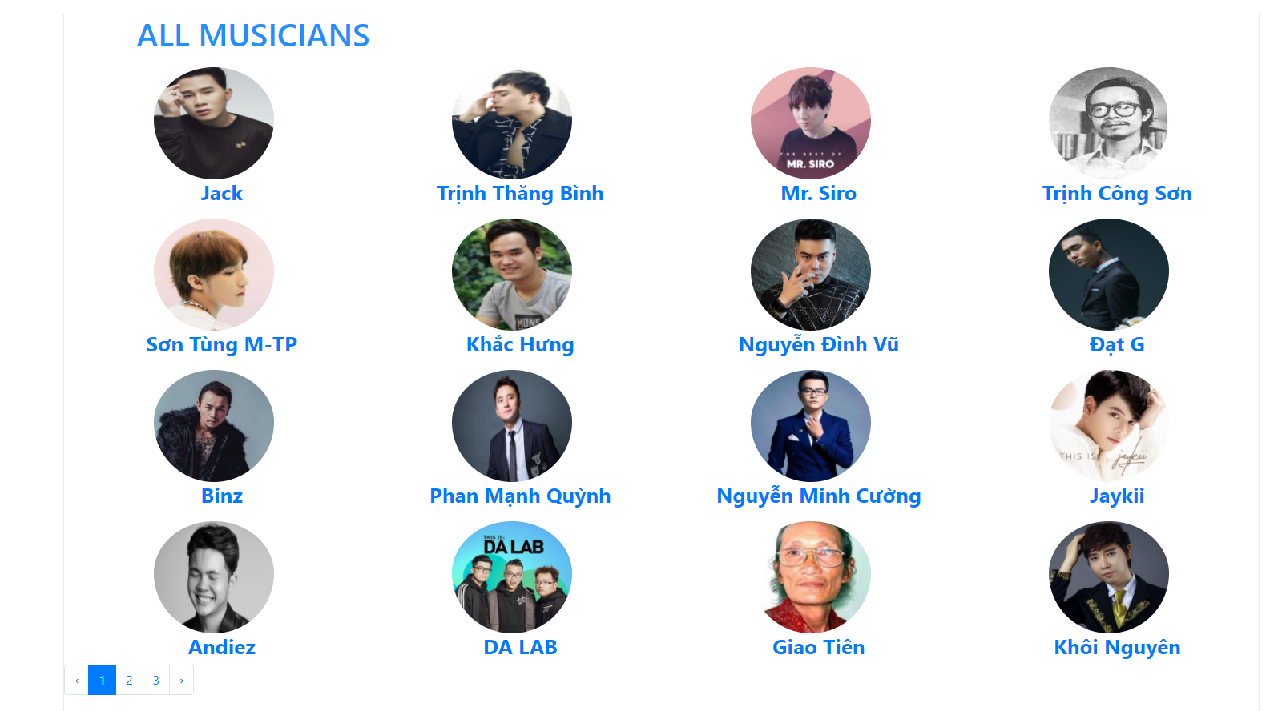

### Musician-detail:

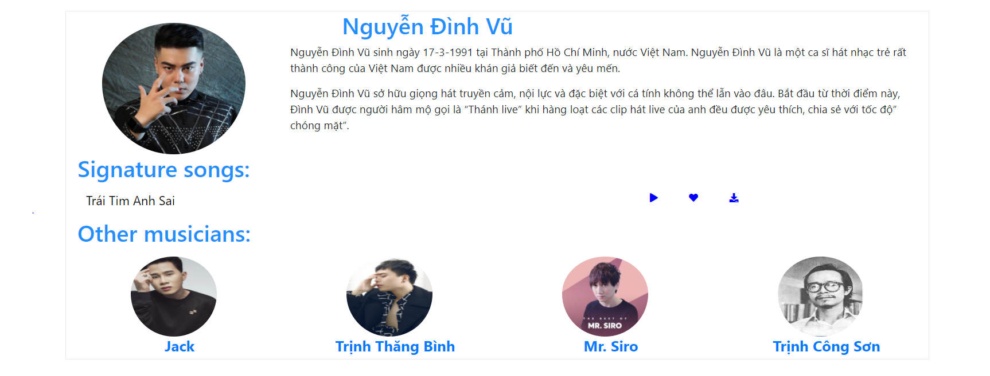

### Categories:

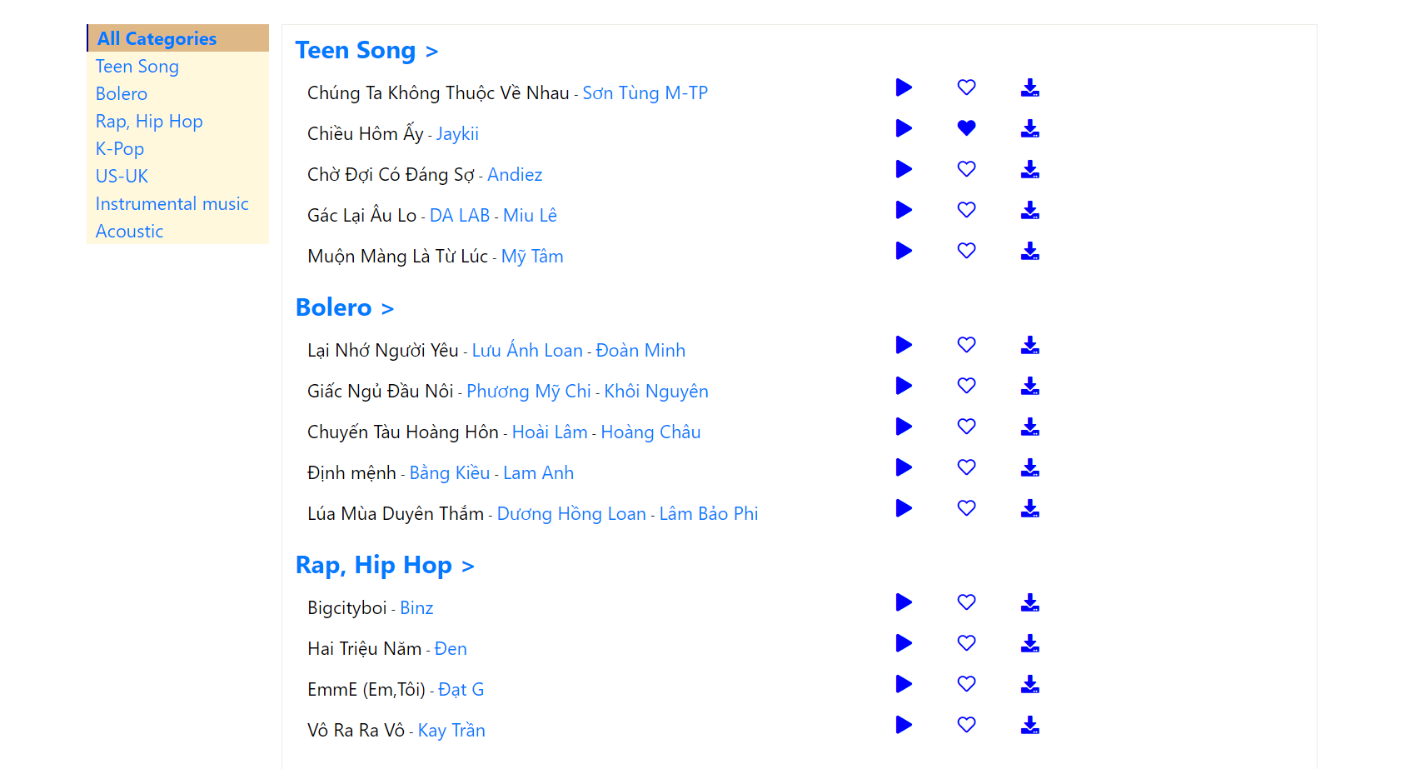

### Category-detail:

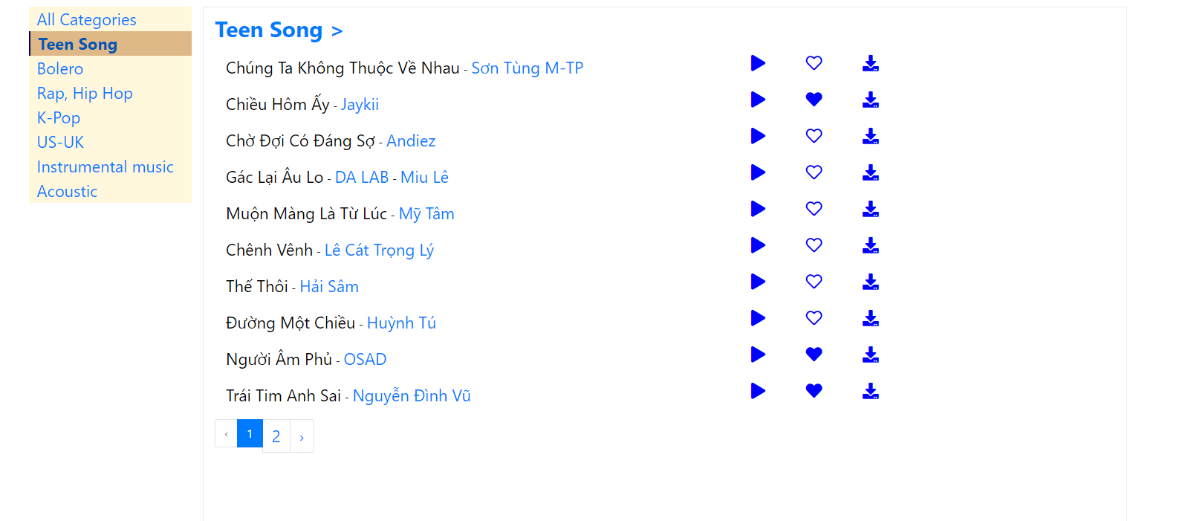

### Nations:

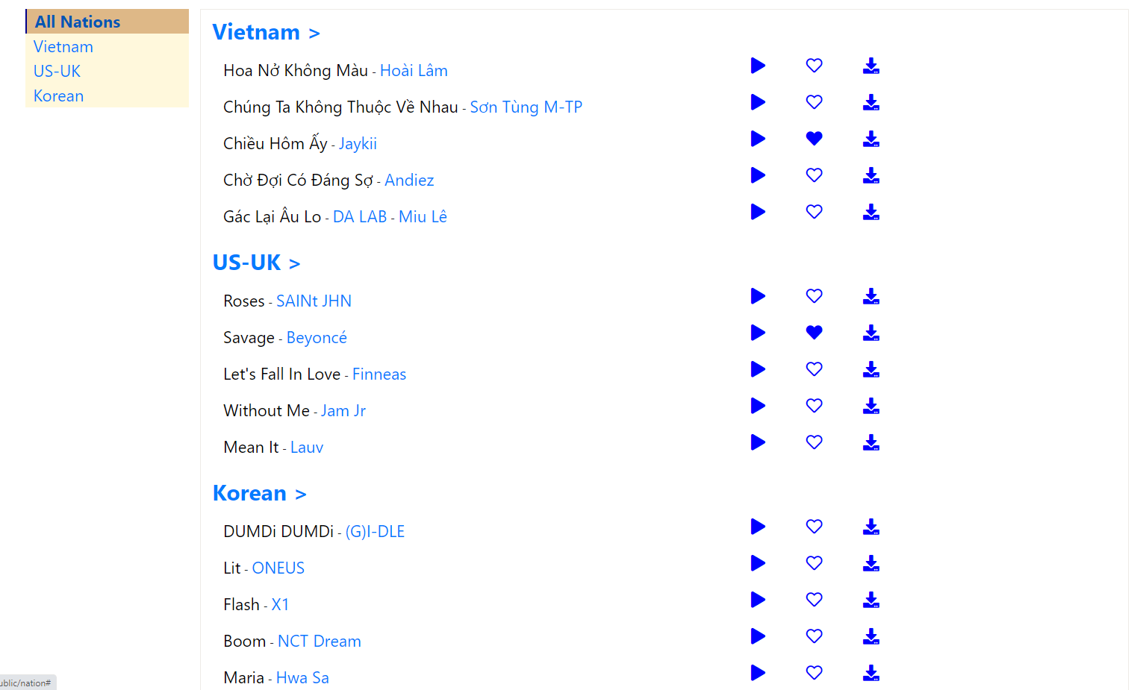

### Nation-detail:

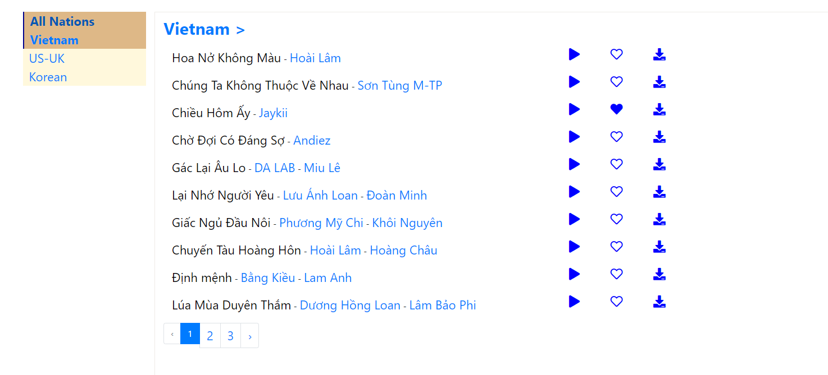

### About us:

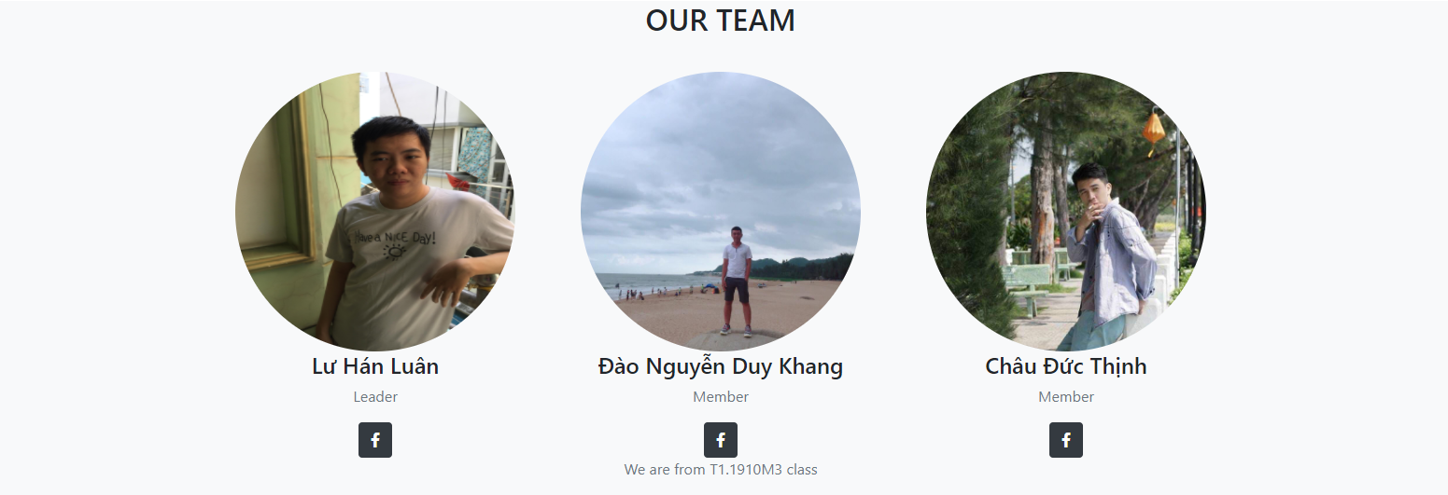

### Recent songs:

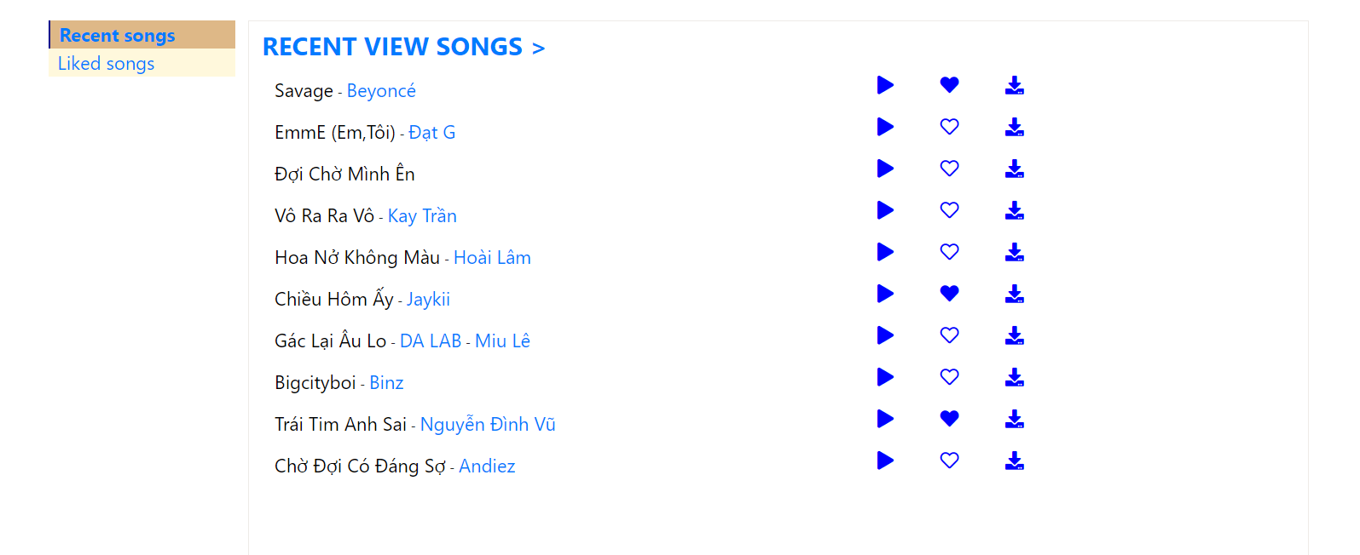

### Liked songs:

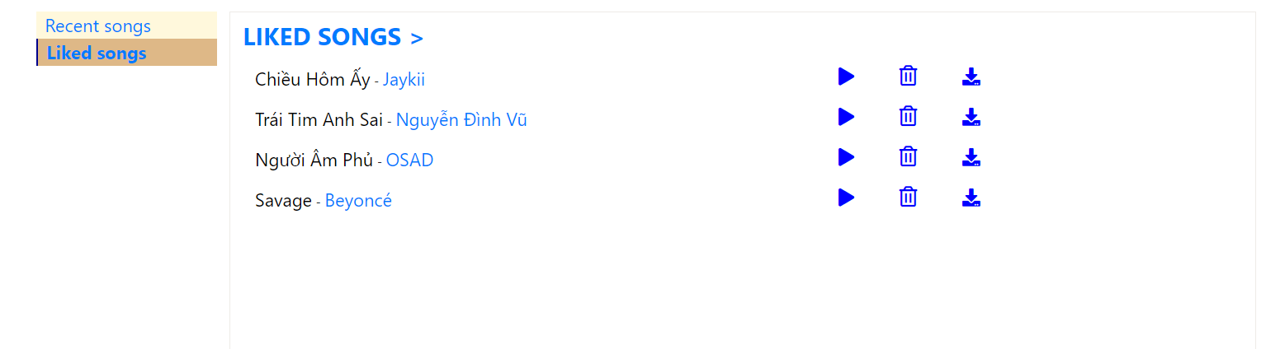

### Search:

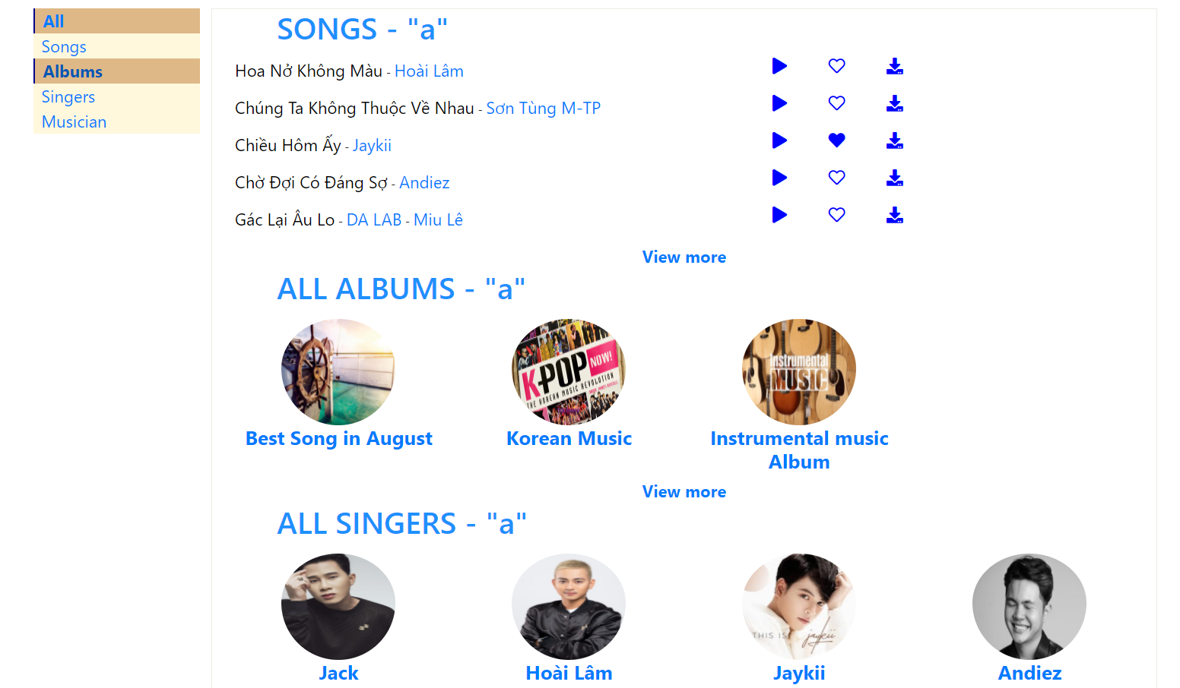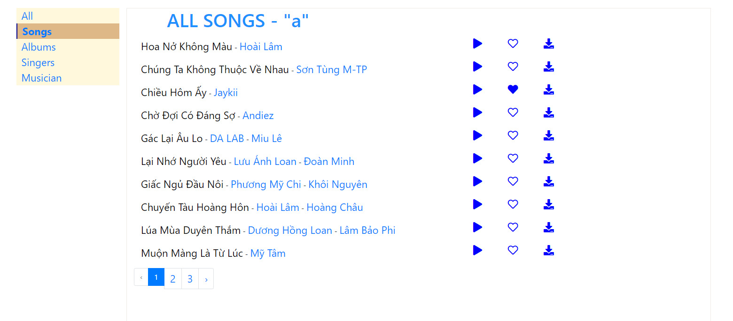

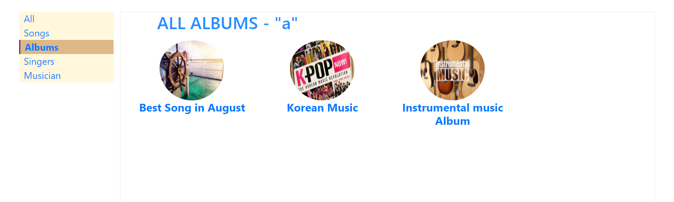

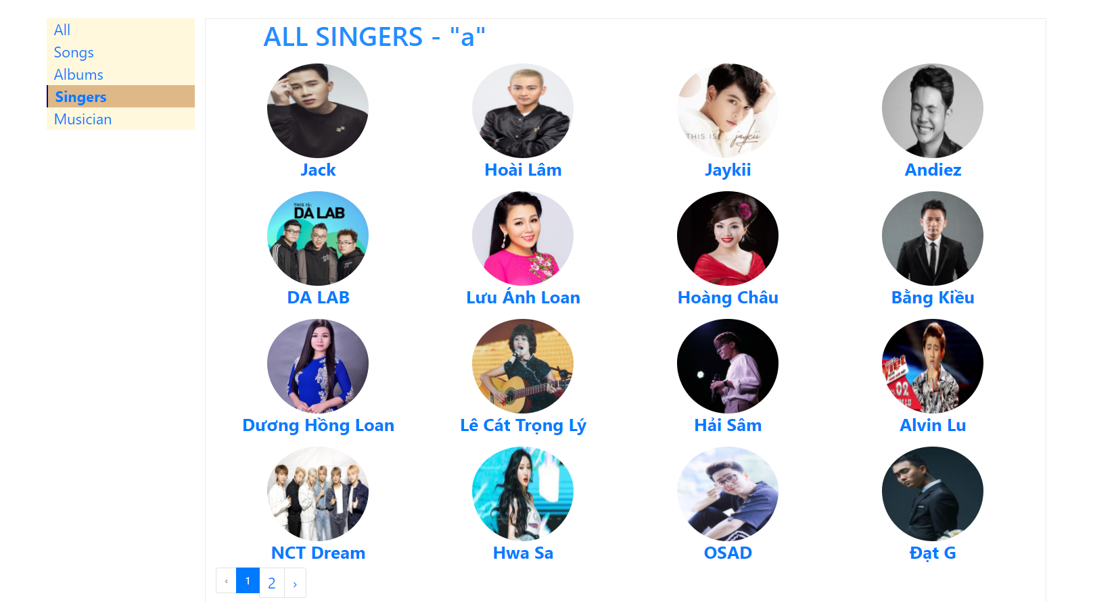

### Login (user):

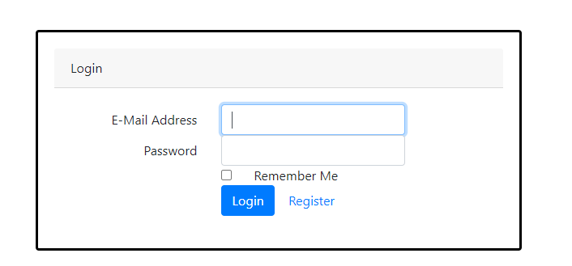

### Register (user):

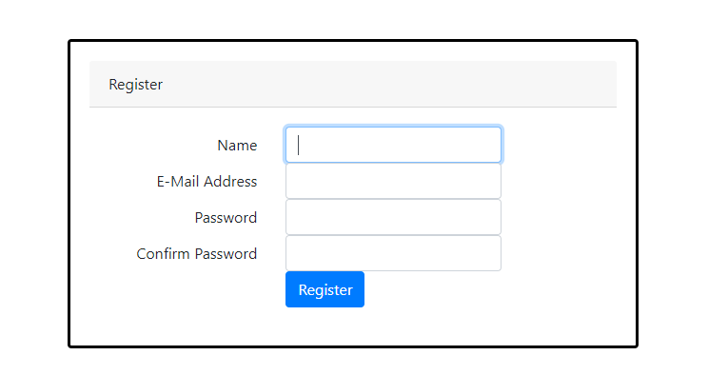

# **TASK SHEET REVIEW 3**

|  |  |  |  |  |
| --- | --- | --- | --- | --- |
| Project Ref.No | Project Name:Plant Store | Date of Prepration of Activity Plan | | |
| No | Description | Start date | Complete date | Team Member |
|  | Admin-Template | 2020/08/01 | 2020/08/03 |  |
|  | Admin-Login/Logout | 2020/08/01 | 2020/08/03 |
|  | Admin-Songs | 2020/08/03 | 2020/08/04 |
|  | Admin-Albums | 2020/08/07 | 2020/08/09 |
|  | Admin-Roles | 2020/08/09 | 2020/08/10 |
|  | Admin-Users | 2020/08/10 | 2020/08/11 |
|  | Admin-Settings | 2020/08/10 | 2020/08/11 |
|  | Admin-Orders | 2020/08/11 | 2020/08/12 |
|  | Admin-Dashboard | 2020/08/11  LƯ HÁN LUÂN  Hoài  Hoài | 2020/08/12 |
|  | Guest-Liked songs | 2020/08/03 | 2020/08/05 |
|  | Guest-Recent songs | 2020/08/05 | 2020/08/06 |
|  | Guest-Views | 2020/08/05 | 2020/08/06 |
|  | Guest-Songs Analysers | 2020/08/06 | 2020/08/07 |
|  | Guest-Search | 2020/08/08 | 2020/08/08 |
|  | Guest-Album detail | 2020/08/08 | 2020/08/08 |
|  | Guest-Comment | 2020/08/09 | 2020/08/09 |
|  | Report – New song Report | 2020/08/10 | 2020/08/10 |

|  |  |  |  |  |
| --- | --- | --- | --- | --- |
| Project Ref.No | Project Name:Plant Store | Date of Prepration of Activity Plan | | |
| No | Description | Start date | Complete date | Team Member |
|  | Admin-Musicians | 2020/08/01 | 2020/08/03 | CHÂU ĐỨC THỊNH |
|  | Admin-Singers | 2020/08/01 | 2020/08/03 |
|  | Admin-Comments | 2020/08/03 | 2020/08/04 |
|  | Report-Overview Report | 2020/08/07 | 2020/08/09 |
|  | Guest-Singers | 2020/08/09 | 2020/08/10 |
|  | Guest-Homepage | 2020/08/10 | 2020/08/11 |
|  | Guest-About us | 2020/08/10 | 2020/08/11 |
|  | Video Introduction | 2020/08/11 | 2020/08/12 |

|  |  |  |  |  |
| --- | --- | --- | --- | --- |
|  | Admin-Nations | 2020/08/01 | 2020/08/06 | ĐÀO NGUYỄN DUY KHANG |
|  | Admin-Categories | 2020/08/06 | 2020/08/09 |
|  | Guest-Nations | 2020/08/09 | 2020/08/11 |
|  | Guest-Categories | 2020/08/12 | 2020/08/14 |
|  | Guest-Login/Logout/Register | 2020/08/18 | 2020/08/18 |